What’s New with ESTR? April 27 2017 Release
The following items are a brief overview of changes that are most pertinent to our research community. For an overview of all system changes (applicable to researchers and IRB staff) please visit → http://estrsupport.fss.harvard.edu/files/estr/files/release_notes_1.22.1_v1.pdf
What has changed… | What it means… |  | How it looks (as applicable)…
SmartForm Pages
Study Team Members  Revised the instructions on the screen and in the non-Harvard team members form | Revisions were made to clarify the definition of a study team member. |  | 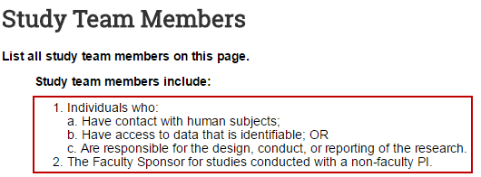
Supporting Documents  Translation Attestation Form is removed. | The Translation Attestation form will no longer be required when non-English versions of study materials are used. Instead, the PI assurance that is confirmed when submitting materials to the IRB has been updated to confirm this attestation. See more information about this under “Activities” below.
Continuing Review/Closure  Added instruction regarding positive disclosure | There is no change in policy. This is simply an on-screen reminder of submission requirements. |  | 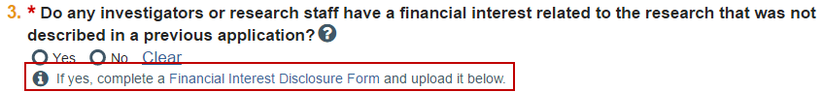
Documents
HRP-545-Use of Human Fetal Tissue in Research and M G L ch 112 §12J_3-15-2017 | This is a new suite of documents pertains to research that uses fresh fetal tissue. The new documents include a checklist for IRB reviewers, a letter template that is used to provide a determination to researchers, and a SOP for internal IRB use.
HRP-224-FORM-IRB Cede Request | This form has been substantially revised to request only the necessary information to process an IRB cede review with another institution.
CR Summary of Study Progress Template | The form has an added question that pertains to clinicaltrials.gov. Please note that this form is not always required to be included with continuing review requests. Instructions in the ESTR SmartForm will let you know when to use it.
HRP-310-WORKSHEET-Human Research Determination | Questions in this form have been simplified and an additional question about newborn blood spot information has been added.
Activities
Submit and Assign PI Proxy  Revised PI assurance language to clarify item 8 (which pertains to Financial Conflict of Interest; study staff now included) and added item 13 (which pertains to translated study documents). |  | From this point forward, the assurance provided by the PI includes a) confirmation of personal responsibility to ensure Financial interest disclosure for themselves and their study staff, and b) attestation that any translated materials are accurate. |  | 