COVID-19 canine MRI procedures
Evolutionary Neuroscience Lab
PI: Erin Hecht
Department of Human Evolutionary Biology / Center for Brain Science

Overview
- Purpose of research: Collect MRI scans from privately-owned domestic dogs under anesthesia.
- Veterinary considerations: Canine MRI scans require anesthesia and intubation, which is an aerosol-generating procedure. There have been limited reports of canine infection with COVID-19, and animal-to-human transmission appears to be very rare if it exists. Nonetheless, the CDC has issued guidelines regarding PPE and screening for animals’ potential exposure to COVID-19. We will follow these guidelines (see Appendix 1: CDC Veterinary PPE Recommendations; https://www.cdc.gov/coronavirus/2019-ncov/community/veterinarians.html).
- Human subjects involvement: Dogs are privately owned; owners complete surveys about dogs’ behavior and bring dogs to campus for the study.
- Research location and use of space during procedures: see Appendix 2: Use of Space During Research Procedures and Appendix 3: Research Procedures.

Measures to prevent infection
- Screening: In order to assess dogs’ potential exposure to COVID-19 positive humans, dog owners will fill out a screening questionnaire. This will be the same as the university-wide human research screening questions, but modified to include not only the human research participant, but also other humans with whom the dog has had contact in the past 14 days. Screening questions will be completed via a web form, prior to visiting the lab. The CDC recommends avoiding any non-necessary veterinary procedures for dogs who may have been exposed to COVID-19. Following this, a “yes” response to any screening question will exclude a dog from the study. Additionally, research staff and study participants will adhere to the screening procedures set in place by Harvard University as preconditions for entry onto campus during Phase II of re-occupancy; veterinary screening will not be a substitute for university-wide screening.
- Reduced personnel: Dogs will be brought to campus by a single caretaker. A bare minimum of research team members will be present (veterinarian, research staff member, and scanner operator).
- Modified research procedures: Prior to the pandemic, dog owners participated in on-campus behavior testing with their dogs and the research team. Participants also had the option of providing consent and completing surveys via web forms either at home or using a tablet supplied in the lab. Now, in-person behavior testing procedures will be suspended, and all dog owners will consent and complete surveys at home prior to the lab visit.
- Physical separation: At least 3 m distance will be maintained between the dog owner and research team members at all times, except for during brief periods of veterinary procedures where the veterinarian and research staff member must be in close proximity while handling the dog. Increased PPE will be worn during these procedures (see below). At no time will proximity exceed 3 m between the dog owner and research staff, or between the scanner operator and other research staff. The scanner operator and dog owner will not occupy the same room at any point in the procedure.
- PPE: Both the research team and the dog owner will wear surgical masks, which will be issued upon entry to the building. Dog owners will be encouraged to wear their own masks during travel to the lab. Research team members will additionally wear gloves during all veterinary procedures, and will wear a gown while performing aerosol-generating veterinary procedures. Researchers will avoid touching doorknobs or other shared surfaces with gloved hands.
- Travel to the lab: Dog owners will be encouraged to avoid public transit in commuting to the lab. Parking will be provided in the Northwest Building lot.
- Touchless entry and exit: Kim wipes will be stationed on the inside and outside of every door that is not propped open, along with a clearly labeled trash can for disposal, so that researchers and participants can avoid touching doorknobs directly. Where possible, doors will be propped open.
- Disinfection of surfaces and equipment: All doorknobs and other shared surfaces, including the participant waiting room couch and coffee table, will be disinfected both before and after a study session. MRI equipment will be disinfected after dog scans following the requirements of the Neuroimaging Core. Veterinary equipment will be disinfected before and after use. Hand sanitizer will be located in the dog owner waiting room, the vet prep area, and the MRI suite.
- Restroom use: Dog owners and research staff will use the restroom behind the elevators on B4, which has been designated for use by the Neuroimaging Core. A call-out-and-wait protocol will be used to ensure that the restroom is only used by one person at a time.

Measures to limit the consequences of an infection
- Notification of infection: If a research team member displays symptoms or tests positive for COVID-19, they will be required to notify the study PI (Erin Hecht), who will notify other CBS personnel so that preventative measures including self-isolation can be carried out. Study participants will be asked to notify Dr. Hecht if they show symptoms or test positive within 14 days after visiting the lab.
- Gaps between study sessions: Scans will be performed at a density of not more than 1 scan per day, with at least 3 days between scans (our current plan is to scan once per week). This allows for an aerosol dissipation gap between study participants.

Appendix 1: CDC Veterinary PPE Recommendations
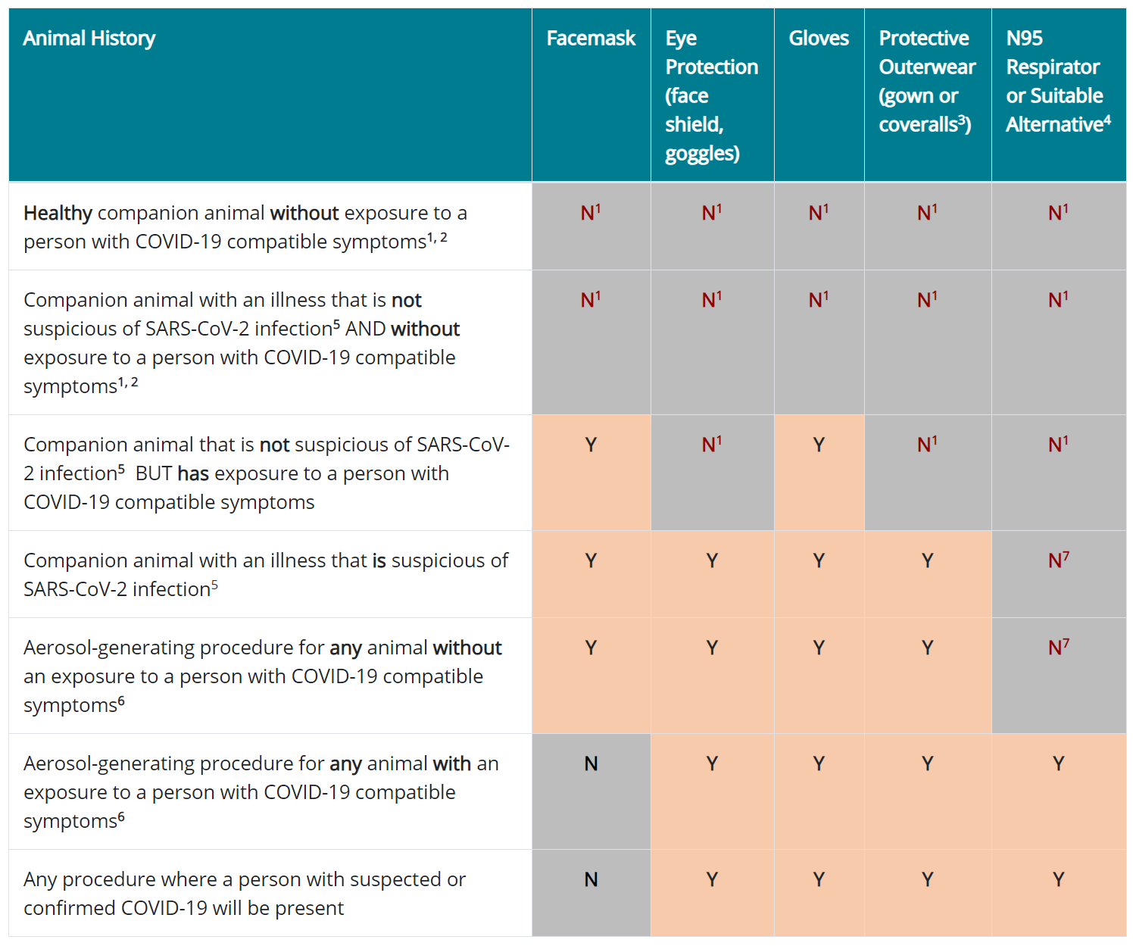
¹PPE Standard Precautions should be applied in any setting where veterinary care is delivered and if exposure to fluids, exudates, feces, saliva, or other animal fluids is possible.
²A SARS-CoV-2 or COVID-19 exposure in this context refers to the following conditions within the 14 days prior to presenting for veterinary care:
- Being within approximately 6 feet (2 meters) of a person with suspected or confirmed COVID-19; close contact can occur while an animal is living with, being pet, snuggled, giving kisses or licks, and/or sharing food or bedding with a person.
- Having direct contact with infectious secretions from a person with suspected or confirmed COVID-19 (e.g., being coughed, sneezed or spit on, sharing food or consuming an object that was recently contaminated with an infected person’s mucous or saliva).
³Reusable (i.e., washable) gowns are typically made of polyester or polyester-cotton fabrics. Gowns of these fabrics can be safely laundered according to routine procedures and reused.
⁴Respiratory protection that is at least as protective as a fit-tested NIOSH-certified disposable N95 filtering facepiece respirator is recommended.
- Please see CDC’s recommendations for alternatives for N95 respirators.
- If an N95 respirator is not available, use a combination of a surgical mask and a full face shield.
- Respirator use should be in the context of a complete respiratory protection program in accordance with OSHA Respiratory Protection standard (29 CFR 1910.134), which includes medical evaluations, training, and fit testing.
⁵ Clinical signs expected to be compatible with possible SARS-CoV-2 infection in companion animals may include:
- Fever
- Coughing
- Difficulty breathing or shortness of breath
- Lethargy
- Sneezing
- Nasal/Ocular discharge
- Vomiting
- Diarrhea
Veterinarians should consider the patient’s potential for exposures to COVID-19 when determining whether the patient has suspected SARS-CoV-2 infection.
⁶Aerosol-generating procedures, such as suction or bronchoscopy, should be avoided if possible on any animals that have been exposed to or are suspected of being infected with SARS-CoV-2.
⁷An N95 mask may be preferred depending on practitioner’s judgement.

Appendix 2: Use of Space During Research Procedures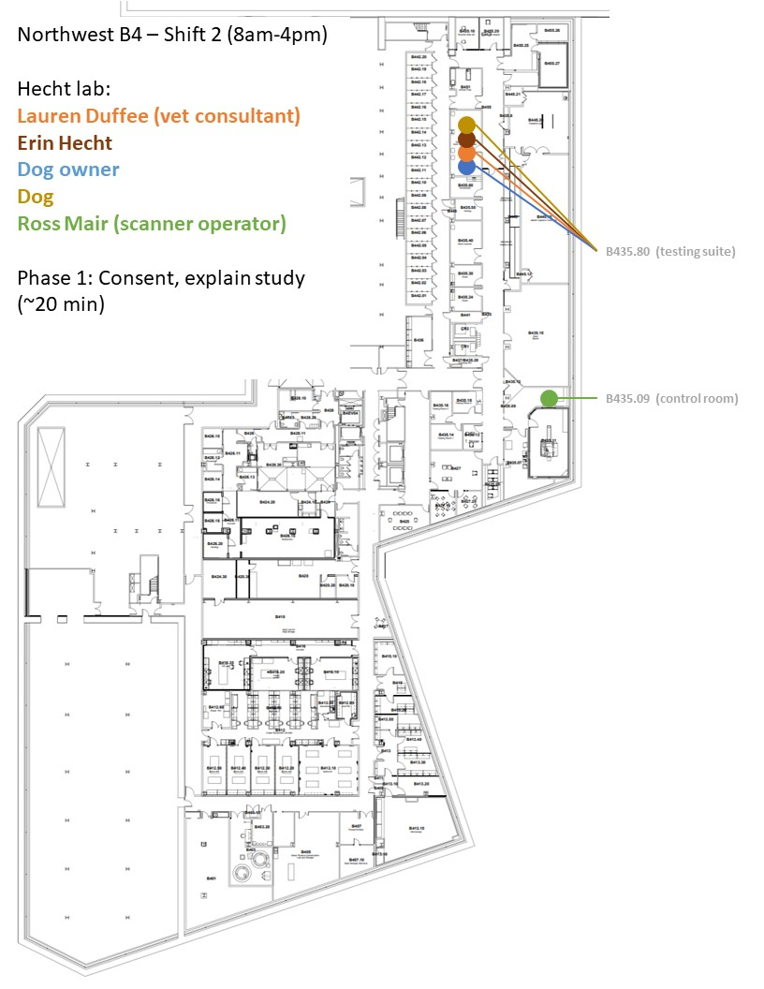eeasdf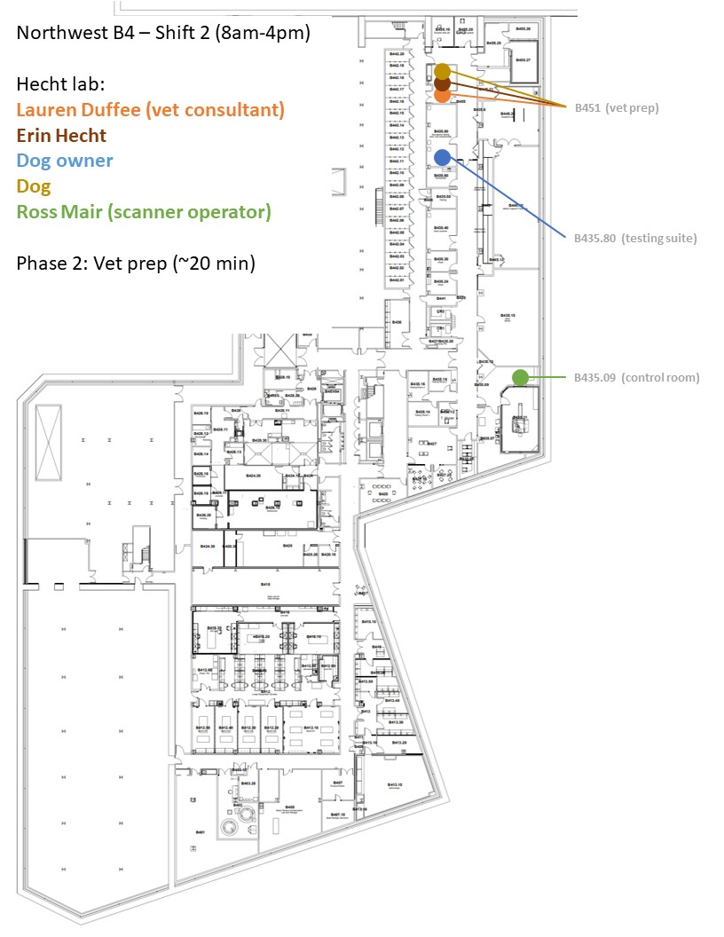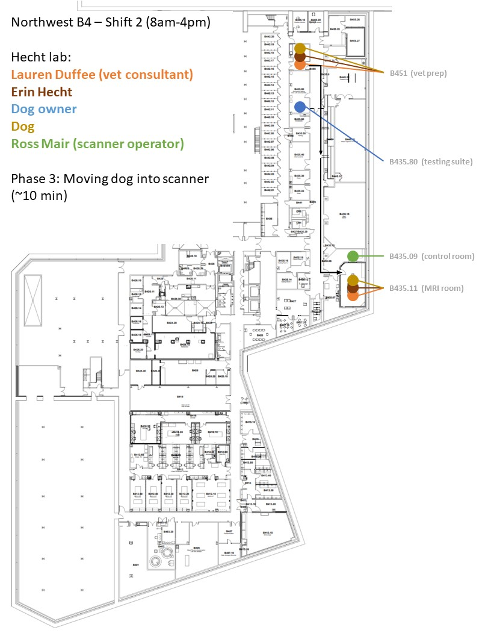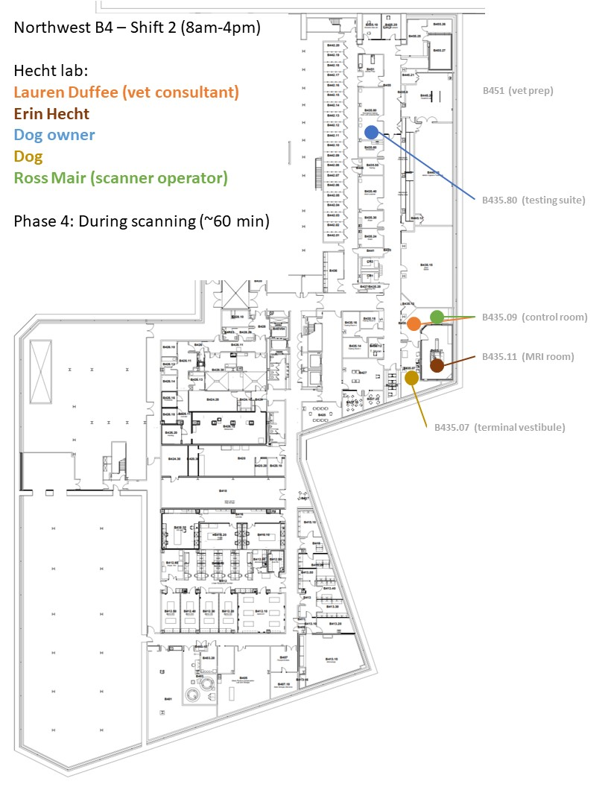 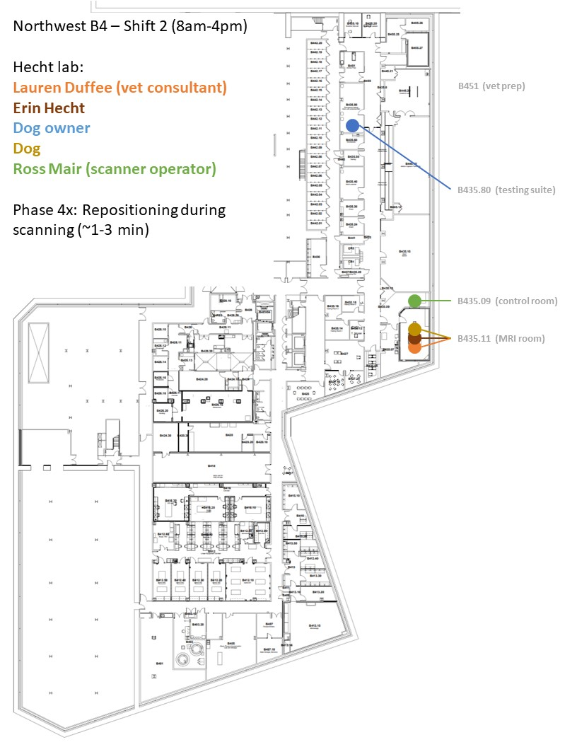Removing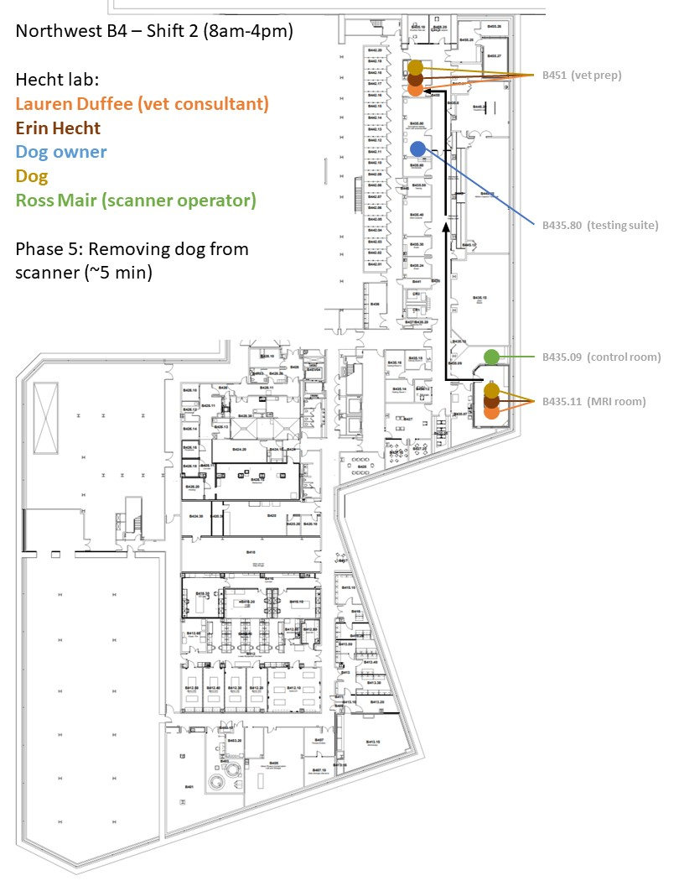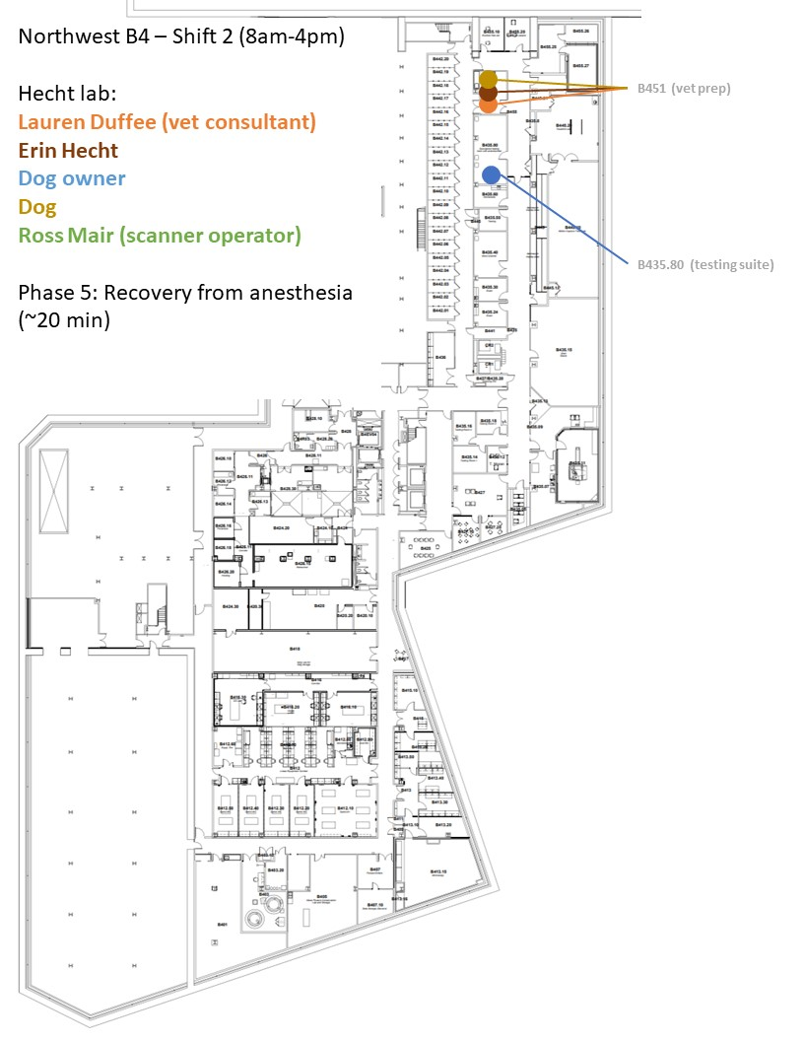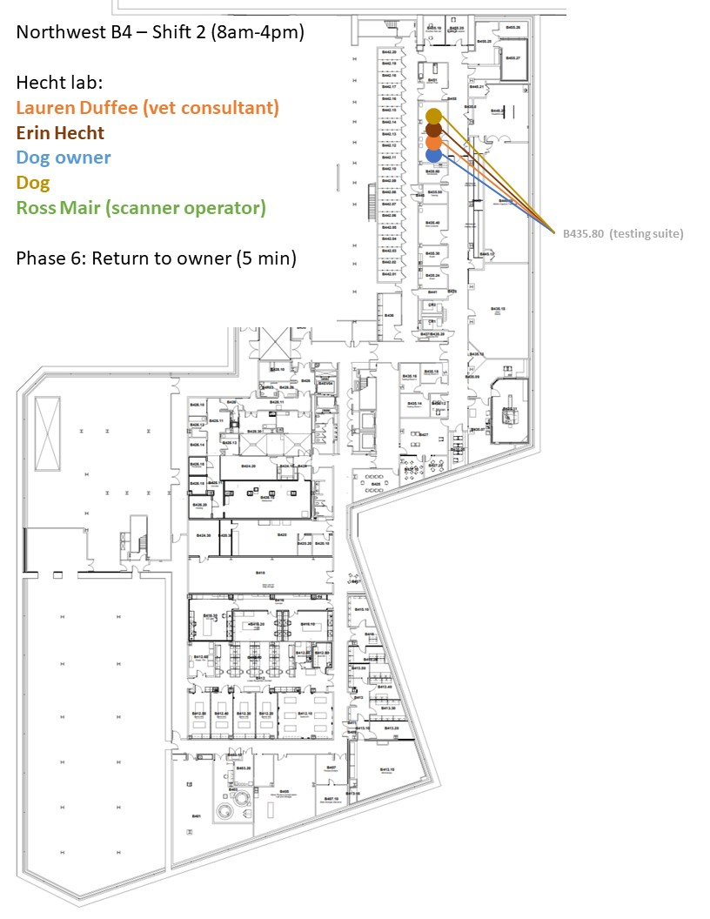

Appendix 3: Research Procedures

Phase 1: Consent, explain study
- The dog owner will be provided with parking in the Northwest garage. The PI (Erin Hecht) will meet the dog owner at the garage and walk them to B435.80, maintaining appropriate interpersonal distance. The dog will be on a leash and under the owner’s control.
- The veterinarian (Lauren Duffee) and PI (Erin Hecht) will meet with the dog owner in B438.80 and answer any questions regarding the procedure. The dog owner will have already filled out the consent form online before visiting campus, but this provides an additional opportunity for questions about the procedures.
- Physical distancing: Dog owner to sit on vinyl couch; EH and LD to sit on plastic stools on opposite corners of the room
- PPE: All humans to don surgical masks upon entry to Harvard buildings

Phase 2: Vet prep
- LD and EH will take the dog into B451, the vet prep area, for a wellness check and anesthesia induction
- Physical distancing: EH to remain on the opposite side of the room until LD requests assistance for portions of procedures requiring a second set of hands. Brief periods of <6ft distance will be required
- PPE: EH and LD to wear gloves, surgical masks, gown, and eye protection during Phase II, as recommended by the CDC for aerosol-generating procedures

Phase 3: Transport into MRI suite
- Using an MRI-safe gurney, EH and LD will transport the anesthetized dog out of B451, down the hallway, and into to the scanner suite, and position the dog for scanning
- Ross Mair, the scanner operator, will remain outside the scanner suite until the dog is situated in the MRI
- Physical distancing: LD will guide the front of the gurney, and EH will guide the rear, allowing for 3m distancing during transport. Once inside the MRI suite, a brief period of reduced distancing will be required while positioning the dog for scanning.
- PPE: EH and LD will continue to wear gloves, gown, eye protection, and surgical masks while positioning the dog in the scanner. Eye protection and gloves will be removed once positioning is complete.

Phase 4: During scanning
- Once the animal is ready for scanning, EH will move into the scanner vestibule. LD will briefly exit the room so that RM can occupy the scanner control zone. LD will then renter and occupy the zone near the door.
- Physical distancing: By occupying separate zones in the control room, sufficient distance can be maintained throughout the scan with all team members able to monitor the dog/scanner.
- PPE: EH and LD will continue to wear surgical mask and gowns, and will keep eye protection and gloves accessible in case it becomes necessary to reposition the dog in the scanner. RM will wear a surgical mask.

Phase 4x: Repositioning during scanning
- During the scan, it might become necessary to access the dog to adjust its position or to carry out veterinary procedures (e.g., adjust anesthesia or ventilation)
- Physical distancing: RM will remain in the scanner operation zone of the control room. LD and EH will re-enter the scanner room; brief periods of reduced distance may be required
- PPE: RM will continue to wear a surgical mask. EH and LD will re-apply gloves and eye protection upon entry to the scanner room.

Phase 5: Removing dog from scanner
- Physical distancing: RM will remain in the scanner operation zone of the control room. LD and EH will re-enter the scanner room; brief periods of reduced distance may be required while putting the dog back on the gurney. Distancing can be maintained while rolling the dog down the hall and back to B451.
- PPE: RM will continue to wear a surgical mask. EH and LD will re-apply gloves and eye protection upon entry to the scanner room.

Phase 6: Recovery from anesthesia
- Physical distancing: Brief periods of reduced distance may be required between EH and LD while performing veterinary procedures and lifting the anesthetized dog. Distancing can be maintained while monitoring the dog during recovery.
- PPE: Because extubation is aerosol-generating, EH and LD will wear CDC-recommended PPE (eye protection, gown, gloves, surgical mask).

Phase 7: Return to owner
- Once the dog has recovered from anesthesia, LD and EH will return it to its owner, waiting in B435.80
- Physical distancing: The owner will be seated on the couch; EH and LD will use plastic stools on opposite corners of the room, allowing sufficient distance to be maintained
- PPE: Because aerosol-generating procedures will be complete, extra PPE is not needed and all humans will simply wear a surgical mask.

Disinfection after study visit: All surfaces and objects contacted during the study will be disinfected, including the couch, coffee table, stools, and door handles in B435.80; the gurney and veterinary equipment in B451; and the MRI platform and equipment in the scanner suite.

