CBS Neuroimaging COVID-19 Operating Procedures

Version 3.2: Aug 3, 2020

Contact Information:

Director for Neuroimaging
Randy Buckner

Operations Director for Neuroimaging†
Tammy Moran
†Designated COVID-19 Safety Officer

Head of MR Physics
Ross Mair

Associate Director for Neuroimaging
Caroline West

Table of Contents

1. Overview. 3

2. Physical separation by work zones and rotating participant rooms. 4

3. Temporal separation by working groups and dissipation gaps. 9

4. Eating and drinking. 11

5. Hand washing. 12

6. Hands-free entry. 13

7. PPE for experimenters and participants. 14

8. Disinfecting procedures. 16

9. Ventilation and local filtration. 18

10. Local storage to minimize between-building travel. 21

11. Training, lab support, and maintenance & Adherence. 22

12. Emergency shutdown procedures. 23

13. Ramp up plan from preparation to staggered implementation of studies. 24

14. Appendix I: List of available PPE, disinfectants, and local filtration. 25

Overview

The Center for Brain Science (CBS) neuroimaging facility is an MRI facility in the B4 level of the Northwest Building supporting a diverse array of investigators that do human, large animal (dog), and engineering work (on phantoms). The greatest use of the facility is study of healthy young adults that involve two experimenters and one participant.

To ensure safety of staff and participants, both MRI safety and COVID-19 safety must be maintained. In over a decade of operation there has never been a situation that required experimenters to physically come together to address an emergency. All operations consider the paramount need to maintain MRI safety in the context of enhanced safety operations specific to the COVID-19 pandemic.

From the standpoint of operational flow, the typical experiment involves a human participant coming into the NW facility, changing, being positioned in the MRI scanner, and then undergoing a series of MRI scans controlled by operators in the adjacent room, changing back into their clothes and exiting the building. The environment is highly controlled and the space, with some exceptions, is large with redundant rooms to separate interactions across space and time. Special considerations involve the cleaning of the MRI bore and scanner between participants, proper use of magnet-compatible PPE, and spatial separation of the two experimenters in the MRI support room which is achieved with a three-zone strategy.

The COVID-19 procedures are carefully structured to minimize human interactions in time and space, create buffers and redundant controls to anticipate human error, and create separate work groups and cross-training to maximize operational stability. The procedures were developed within the framework of the Harvard University Research Laboratory Re-Entry Plan as well as the CDC’s Reopening Guidance for Cleaning and Disinfecting. The procedures are a foundation for safe conduct of human studies research. All investigators doing human studies research must obtain or modify their own human studies (IRB) approval to accommodate the risks and disclosures of conducting research in the context of the COVID-19 pandemic.

Physical Separation by Work Zones and Rotating Participant Rooms

Separation of participants and experimenters within the neuroimaging facility is maximized by strategies for concurrent occupation of space and by rotating use of space over time. Three specific challenges are addressed: (1) Participant movement into the space and changing, (2) Participant movement and positioning in the MRI scanner, and (3) Separation of the experimenters within the control room while conducting the MRI experiment using a three-zone strategy. We first describe modification of the overall space then separately describe procedures to accommodate each of the three specific challenges.

1. Overall modified use of space.
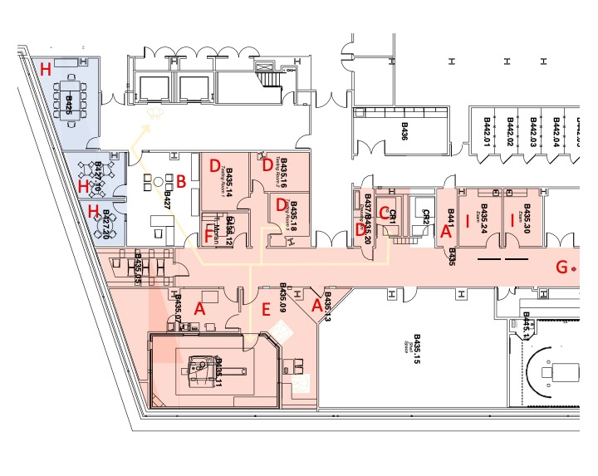
Rooms that are not necessary will be locked or use disallowed, including the waiting room, which becomes possible by using remote consent procedures, reducing scan capacity, and implementing an on-demand procedure for participants to enter into the building (See 2 below). Specifically, (A) All rooms that are labeled A are equipment or storage rooms that will be labeled for access primarily by core staff. (B) The furniture will be moved from the waiting room, couch turned around, and piano keyboard taped closed to make clear there should be no use of the main waiting room except as a pass-through hallway. This minimizes areas that need to be disinfected. (C) The B4 neuroimaging suite has an interior private restroom that will be used for neuroimaging participants. (D) The single traditional changing room will be augmented by the three behavioral testing rooms, to have a set of four functionally-redundant rooms that will be rotated across the four daily participants, so that each participant has a room to change in and fill out any necessary forms that will not be occupied by another participant on that day. (E) The MRI console is moved to the second observation window. This allows 10 ft separation between the two experimenters and establishes the space for the three-zone control room strategy described below. (F) The room across from the scanner has been cleared of personal items and will be individually used for investigators to drink and/or snack. (G) The kitchen area is closed for food and drinks and the sign reallocated to be a hands-free washing station. (H) The room adjacent to the elevators, previously used for safety training, and the larger interior room in the waiting area will be reallocated for behavioral testing, given the rooms are sufficiently large to allow safe physical separation by two individuals, and keeps these extra individuals separate from the internal neuroimaging space. The smaller interior room in the waiting area will be reallocated as a waiting room for child guardians. The experimenter will direct the parent or guardian to the waiting room but will never enter so that only one person will occupy this room at a time. These three rooms will be treated as a completely separate zone (Blue Zone) from the MRI suite (Red Zone) with its own scheduling system independent of the Red Zone. (I) The TMS room and exam room will be augmented by movable privacy screens placed outside the doors to effectively create a larger space with the doors kept open for better air flow. A fan placed outside the doors will supplement the room ventilation, since the activities in these rooms require close contact between experimenter and participant.

2. Participant movement into the space and changing.

Participants will be contacted via phone or text and met at the main NW building entrance and will be issued an appropriate mask, which will be in place before entering the building, and the study team member will check the participant’s temperature using a no contact IR thermometer. If the participant’s temperature is 100.4 ℉ or above, or they are unwilling to wear a mask, we will not proceed. Once these steps are completed, they will take the stairs (preferred) or main elevator down to B4 (if elevator they will take individually, exit and wait for the experimenter who will immediately follow in a second elevator). An example path of a participant is illustrated by the yellow lines in the diagram above. The participant will wash their hands with soap and water for at least 20 seconds in their private restroom. They will then be escorted at safe distance through the three doors into a single-use room (one of the four rooms labeled D). Each room will have clothes for changing as well as a single-use MRI-compatible mask that the participant will change into. Three of the rooms have space for consenting and any testing, at safe distance. For the initial ramp up phase, daily capacity will be no more than four participants, allowing each room to be rotated across participants and used by only one participant on a given day, minimizing exposure between participants. After changing, the participant will be escorted at safe distance to the MRI bay, safety screened for metal, and placed in the scanner or will be escorted to the TMS room for transcranial magnetic stimulation or to the Exam room for sample collection. Standard operating procedures for the TMS room, Exam room and Blue Zone behavioral testing activities will be described in separate procedure proposals for these rooms.

3. Participant movement into and positioning of the participant in the MRI scanner.

The experimenter and participant will both wear masks during MRI scanner positioning – an MRI compatible mask for the participant and surgical mask for the experimenter. In addition, the experimenter will wear a plastic face guard and disposable gloves while in the MRI bay at all times when a participant is in the room. There will be direct physical contact when the participant’s head is positioned in the MRI head coil, which can be done in under five minutes. To minimize contact time, all needed materials and pads will be pre-positioned on the counter during pre-cleaning. The experimenter will dispose of gloves and hand sanitize on exiting the scanner room before engaging the MRI console.

4. Separation of the experimenters using a three-zone control room strategy.

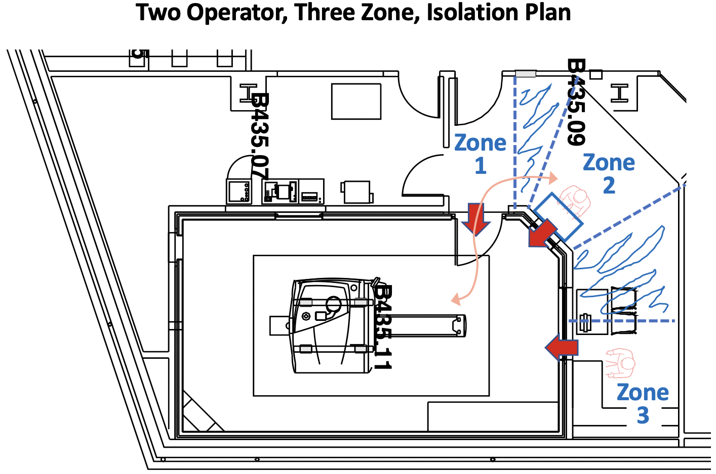

Three zones will be created in the MRI control room marked by tape on the floor, with buffer zones between them. The participant and experimenter enter the MRI room from Zone 1. The scanner control console is duplicated in front of the second window in Zone 2, allowing the experimenter the option to control the MRI scanner from Zone 2 at a safe distance from the experimenter in Zone 3 who has access to the behavioral equipment and also a line of sight into the MRI room. In each zone there is a direct line of sight through the door (Zone 1) or windows (Zones 2 and 3) on the MRI magnet and participant (red arrows). Relocating existing desks at the back of Zone 2 will allow rapid passage of the Zone 3 individual while maintaining ~5-6ft (breath-hold) separation.

Variations. (1) V1A: In the most common experimental configuration (as used by typical functional MRI studies) the above strategy will be employed. V1B: In some situations the individual controlling the behavioral equipment in Zone 3 would be the person meeting and setting up the participant in the scanner. In such situations, the individual in Zone 2 will scoot forward to allow the other experimenter to pass. (2) V2: For certain studies that involve only structural acquisitions, further separation will be possible by having the second individual for safety just outside in the terminal vestibule and then the primary operator at the Zone 3 desk. Cameras will be configured on the MRI console room, to allow observation from the vestibule. (3) V3: For studies involving more intensive juggling of participant and MRI operations that require a third experimenter, only two experimenters will ever simultaneously occupy the MRI console room, using the above three-zone strategy. The third experimenter will be positioned in the terminal vestibule away from the others.

5. Enhanced viewing from MRI control room to adjacent terminal vestibule.

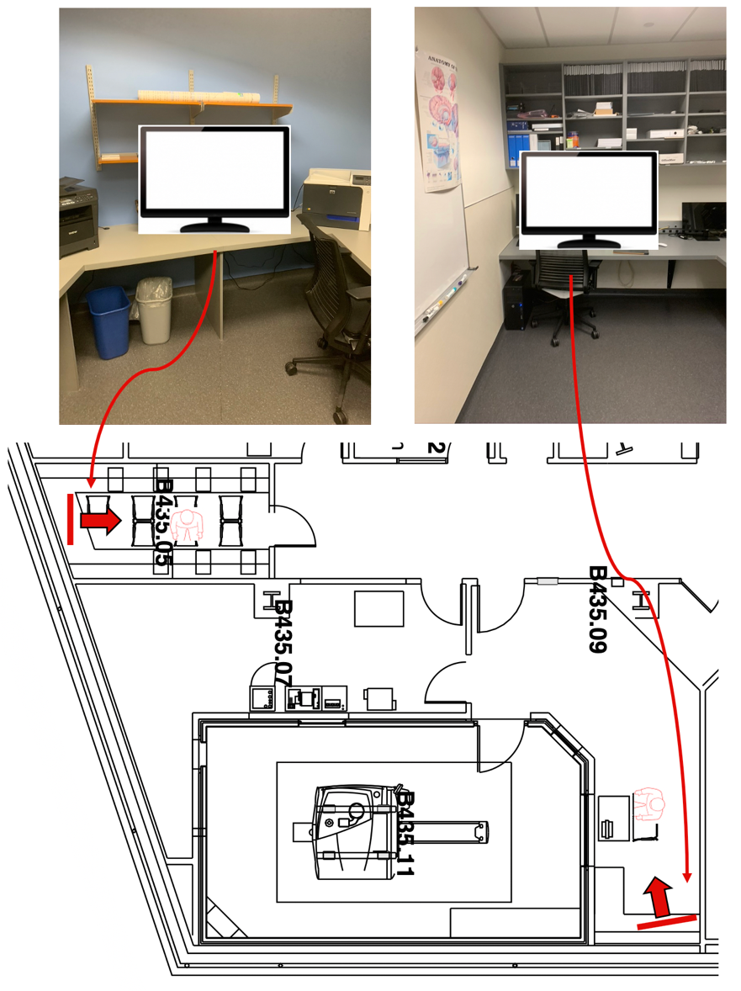
A specific challenge that arises in the present plans to de-densify the MRI testing support: there is less connection / visibility between the experimenters. Under typical operations, there are often individuals and student observers (although conducting MRI scans with two individuals is also common). MRI safety is paramount. In all instances an experimenter will be in the control room when a participant is in the MRI suite. In instances where the second, safety support experimenter can be relocated to the vestibule, the line of site between the two experimenters is broken. We will modify the space to create a virtual connection.

Two (inexpensive) large-screen flat TVs with top-mounted (Logi) cameras facing outwards are being placed in the vestibule and also in the control room with broad views of the space (and the hall in the background). They will be initiated with secure password-protected Zoom sessions during setup, allowing continuous full large-screen viewing and audio communication between the two rooms. A Zoom access list will only be granted to authorized staff and experimenters. Given this procedure is to de-densify the control room from two to one (when doing structural scans) and allow for a third experimenter to view the control room for more complex studies (and backup for restroom breaks), the extra viewing will be considered secondary to actually being in the room. That is, if there is a technical issue, two people will maintain safe distance within the control room as described above for the three-zone strategy (the room is twice the size of a typical MRI control room because it was designed to accommodate student observation).
Temporal Separation by Working Groups and Dissipation Gaps

MRI scanning is scheduled in terms of participant slots that are utilized by a single experimental group at a time. Thus, the temporal flow of the schedule can be used to mitigate COVID-19 exposure risk including how close in time sequential participants are scheduled, the pattern by which distinct lab working groups come after one another, and by imposing downtime gaps between scan slots. All mitigation opportunities are deployed in the schedule.
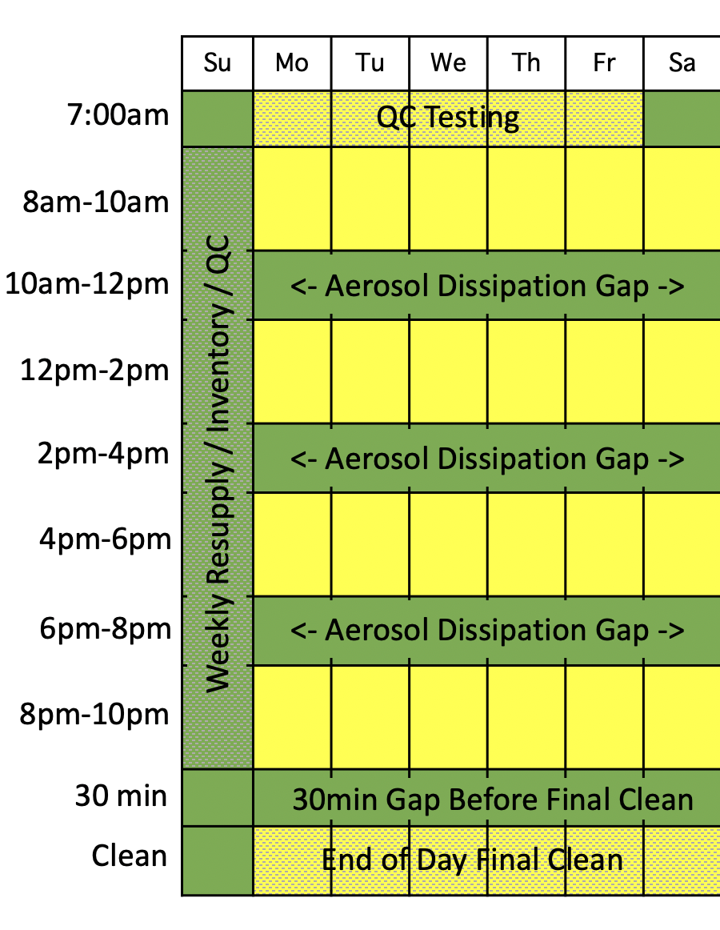

1. Scan blocks.

The schedule affords 24 2-hour scan blocks per week –each separated by two hours between participants. A given lab group could use one or more blocks on any given day.

2. Aerosol dissipation gaps.

A 2-hour gap is conservatively imposed between scan blocks so that two separate participants never encounter one another and any aerosol from one participant in the scanner room is fully dissipated before the arrival of the next participant.

3. End of day final clean.
The final group of the day will wait 30 min before entering the scan room to do a final clean. Surface areas and other areas can be cleaned in the interim. The 30 min gap allows changeover of air in the scanner bore and MRI room before the thorough end-of-day scan room cleaning takes place. The end of day final clean will take place after the last used time slot of that day.

4. Core staff QC and MRI suite access.

Five early morning times on weekdays are set aside for running QC phantoms and any daily checks that must be made by core neuroimaging staff. A longer block is also set aside one day a week, such as might be used for scanner testing and sequence checking, as well as to allow downtime for resupply and any other facility needs. The timing of these blocks (morning and evening before user scan days) positions these before any users and participants have entered the facility and minimizes exposure to neuroimaging core staff who will be regularly entering the facility.

5. Blue Zone behavioral suite access.
The three rooms in the Blue Zone are completely outside the Neuroimaging Red Zone, separated by a keycard access door, and will be scheduled separately with one group having access to all three rooms at one time to minimize overlap between groups and maintain low density in the space. Because of the physical separation of the Red and Blue Zone spaces, one group can be scanning in the Red Zone, while another group is testing in the Blue Zone. The one exception to the separate scheduling would be in the case that the group scanning needs to use the guardian waiting room for a session with a child subject. In this case, the guardian waiting room would be scheduled concurrently with the MRI suite. In addition to maintaining a room schedule, a master occupancy list will be maintained to keep track of the individuals occupying the overall space in both the Blue and Red Zones at any given time. Initially the Blue Zone rooms will primarily be used by the Somerville and McLaughlin labs for Human Connectome Project and STAR project testing of children that occurs post-scanning, so coordinating this scheduling will be straightforward. In addition, dissipation gaps of 2 hours between subjects will be employed in each individual Blue Zone room as is done in the MRI scan room to mitigate exposure to infection from the previous occupants of the rooms.

6. Limiting the consequences of an infection.

The final consideration is the use of the gap day (e.g., Sunday) and 2-hour gaps between subjects to limit the consequences of an infection. Even with perfect protocols, we must prepare for, and expect, instances of infection to arise within our community due to non-workplace interactions. If an individual displays symptoms or tests positive for COVID-19, they will be required to notify HUHS immediately. HUHS and the Department of Public Health will determine who needs to self-isolate and avoid returning to the facility and for how long. The aerosol dissipation gap between subjects allows separation of working groups so that potential close contact with an infected individual is contained within the group scanning in that block. In addition, the allocation of QC blocks for core staff use the day before or morning before also mitigates exposure consequences. For example, if QC testing was done the evening before the scanning day and morning of the first day, the core neuroimaging staff are fully isolated from user group infections.

Eating and Drinking

Room B435.12 will be cleared and assigned as a single person drinking and eating area, with sufficient wipes and trash to allow full disinfection of the surface area before and after use. Individuals needing to drink will first wash their hands in the hand washing station, then bring their personal use bottle into room B435.12, disinfect the surface area to be used, pull down their mask, eat or drink, sanitize their hands with sanitizer, pull up their mask and then disinfect the surface area, wash their hands in the hand washing station and then resume activities. This sequence – wash hands, disinfect, eat or drink, disinfect, and then wash hands will be used each time a snack or drink is taken.

Hand Washing

Frequent hand washing is a requirement. Participants will wash their hands on entry into the neuroimaging suite and just before exit using their single-use designated restroom.

Experimenters will wash their hands when using the external restroom, but more frequent handwashing is advisable. The break room (room B435.60) will be reallocated to be a neuroimaging-experimenter-only hand-washing area. All food-type items (coffeemaker, etc) will be removed. The door will be propped open and an automatic soap dispenser installed. A sign outside of the newly designated wash room will indicate “Neuroimaging experimenters Only. One person at a time.”

Except when escorting participants, experimenters will be required to wash hands every time they enter the main hall, since they can access the handwashing station without touching any additional doors or handles. With this simple rule, they will frequently wash their hands and, critically, will do so before leaving to get participants and before entering the MRI control room as a matter of course.

In terms of existing setup, the current area has neither an automated soap dispenser (A) or automatic faucet (B). We have purchased an automatic soap dispenser and refill soap. We would ask that the building operations replace this key faucet to be automatic given it will be used frequently by experimenters. In the interim Kimwipes and paper towels will be used as barriers for contact.

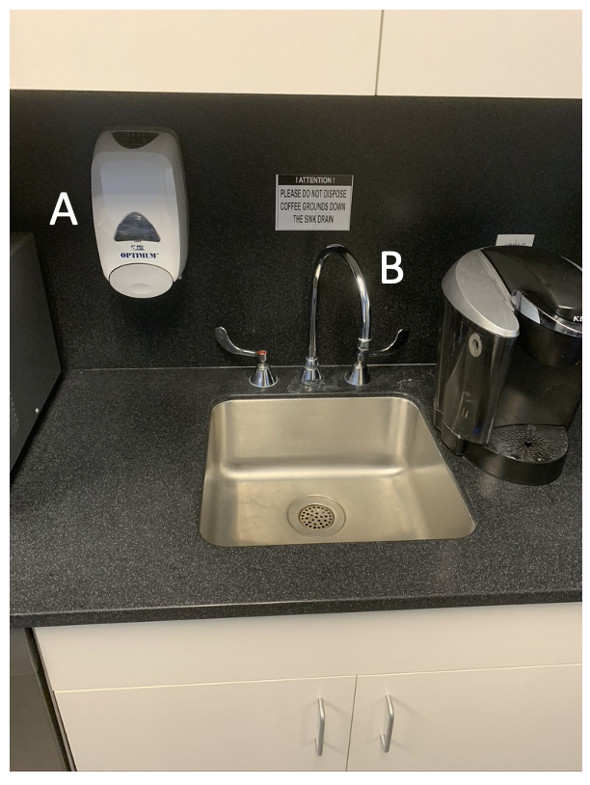

Hands-Free Entry

Door handles at entryways and closets represent a potential source of contamination. At each used location, on both sides of entryways, single-use one-at-a-time dispensing Kimwipes will be available to take before touching the handle and a waste receptacle will be positioned to receive the used wipe. The below positions indicate where Kimwipes (on stands) and waste receptacles will be located (The wipes are attached by either wall-mounted Kimwipe holders to the wall or placed on top of upside-down 20-inch plastic waste receptacles). Each to-be-used waste receptacle will be labeled “Wipe Disposal Only!”.

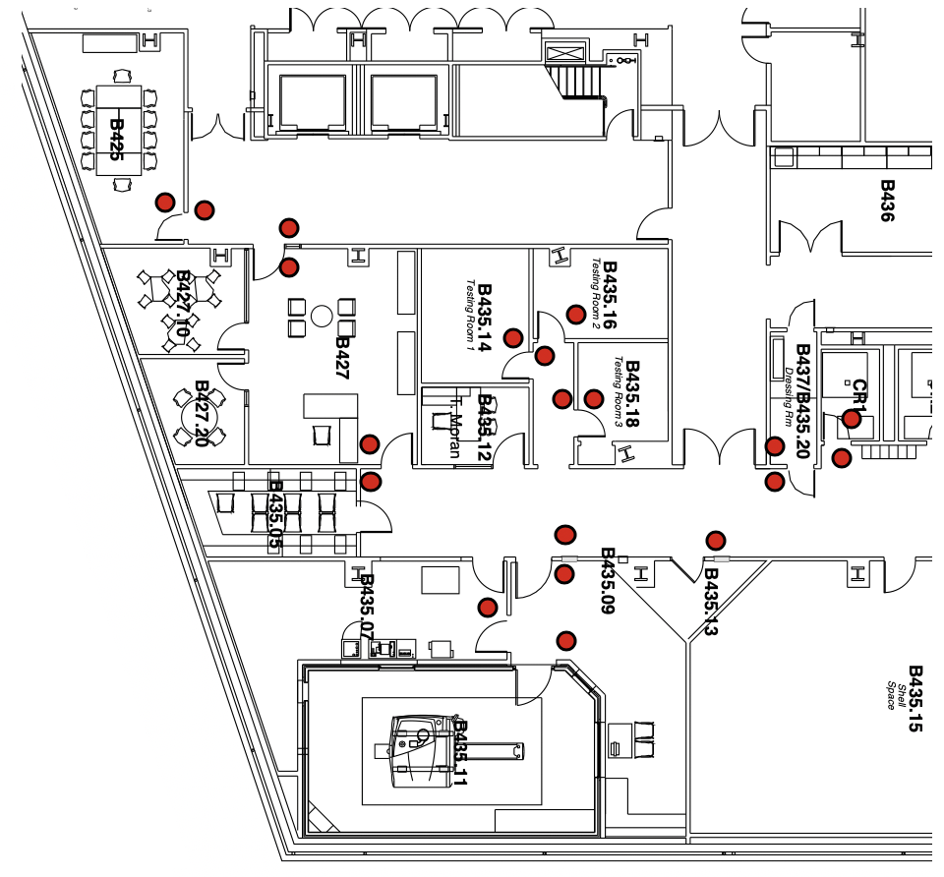

PPE for Experimenters and Participants

(1) Routine experimenter PPE.

Masks. All researchers will wear Type II 3-ply surgical face masks at all times.

Disposable gowns and gloves. During cleaning and disinfecting of equipment and surfaces and the handling of trash, researchers will wear disposable gowns to protect their clothing as well as latex or equivalent non-allergenic disposable gloves.

Keyboard covering. The console keyboard and mouse will be protected with disposable covers (fitted saran-wrap like coverings used in the dental hygiene field to mitigate spread of infection).

(2) Enhanced experimenter PPE for brief MRI room participant interactions.

A single experimenter will metal check and escort the participant and position them in the MRI scanner head coil. To avoid risk of exposure, while in the MRI room with the participant, the experimenter will wear a face shield in addition to a Type II 3-ply surgical mask, as well as latex or equivalent non-allergenic disposable gloves. The face shield will be reused by the researcher for that day cleaned fully on the outside with disinfectant wipes between uses.

Once the study is complete, the same researcher enters the scan room again to remove the participant, with the same face shield and new disposable gloves.

(3) Participant PPE.

MRI-compatible mask. Participants will wear Type II 3-ply surgical masks supplied by the researcher before entering the building. While privately changing in their room in preparation for scanning, they will exchange the surgical mask for an MRI-compatible mask and change their clothes into scrubs provided by the facility. Changing will occur in a room designated for their exclusive use for that day.

Response key covering. During scanning, the safety ball and response keys will be covered with saran wrap which will be thrown away during post-scan cleaning.

The MRI compatible mask is constructed in advance by making a very small incision above the stitching to remove the small metal piece (with a tweezer). See A below. These will be constructed in bulk and placed in the participant preparation packets well in advance of the session (>5 days). The incision to remove the metal nose piece is above the blue covering and stitching leaving intact the full protection of the mask. A small piece of tape is used to create a slight pinch and snug fit virtually indistinguishable from what is achieved by the metal insert. See B below. Moreover, the subject wears the mask prone so there is no issue of slipping by gravity during the MRI session. Depending on final guidelines, masks may be worn during setup and removal, but pulled down during active scanning.
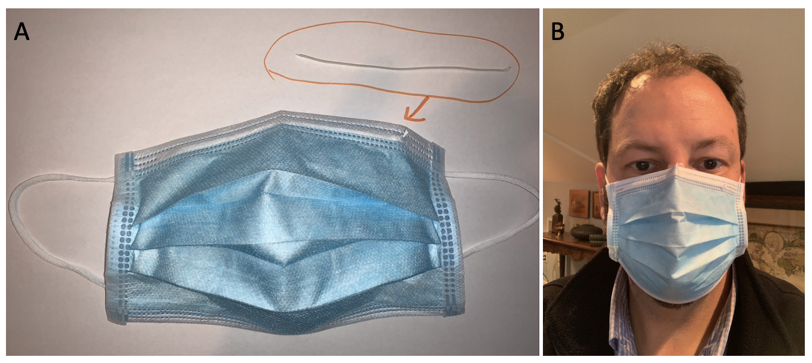

See ACR guidance:

https://www.acr.org/Clinical-Resources/Radiology-Safety/MR-Safety/COVID-19-and-MR-Use

Disinfecting Procedures

Disinfecting procedures will closely follow CDC reopening guidance. The schedule is set up such that experimental work groups occupy the facility for a block that is separated from another group by a temporal gap of three hours. The disinfecting procedures have two components – (1) procedures conducted on entering and existing a use block, and (2) procedures that take place between participants.

(1) Disinfecting procedures entering and exiting a use block.

CDC-approved Clorox and Lysol disinfectant wipes are available in all rooms. A plastic Swiffer arm and large-size wipes are stored in the MRI room for cleaning the inner walls of the scanner bore. Experimenters will wear the provided latex or vinyl gloves and a disposable gown while cleaning and disinfecting and when handling trash.

On entry into the facility each work group will disinfect (a) accessible knobs, handles, and faucets including doors to MRI room, (b) the scanner bore, table, peripheral equipment, and head coil, and (c) work surfaces including keyboards and mouse. In the scanner room this will include the scanner table, padding and leg cushion; squeeze ball and button boxes; head coil; physiological equipment; work surfaces including keyboards and mice; scanner bore walls using Swiffer arm and large disinfectant wipes. Experimenters will be trained on proper linear top to bottom MRI bore disinfecting protocol (based on American College of Radiology guidelines). Equipment that cannot be disinfected with wipes, in particular the eye-tracker mirror and MRI-compatible eye glass frames and corrective lenses, will be disinfected in a UVC irradiation box (Analytik Jena UVP Crosslinker UV Irradiation System CL-3000). The experimenter will also clean the individual room (or rooms) intended for use by their subjects that day (and not enter the other rooms). When leaving for the day they will repeat the cleaning protocol including recleaning the testing rooms used only by their subjects.

All head coil pillows and padding used will be those made with washable materials and will also have removable pillowcases or cloth covers. After each participant, the experimenter will remove the covers and disinfect the pillows and padding with wipes. Plastic saran-wrap or custom saran-wrap-like coverings will be placed in the scanner room on the safety squeeze ball as well as console keyboard and mouse.

Following cleaning, gloves and gown will be removed carefully to avoid contamination of the wearer and surrounding area and disposed in designated trash bins. Immediately after removal, the experimenter will wash their hands with soap and water in the hand-washing area.

Trash bins will be placed in each room for disposal of wipes, paper towels, Kimwipes, gloves and gowns. Trash bins will be put out into the hallway at the end of the day for removal by the custodians.

(2) Disinfecting procedures between participants.
Between individual participants, the full set of procedures indicated above will be repeated, without cleaning of investigator-used work surfaces and without reentering the single-use testing rooms.

CDC reference materials on reopening:
www.cdc.gov/coronavirus/2019-ncov/community/reopen-guidance.html

America College of Radiology (ACR) guidelines:
https://www.acr.org/Clinical-Resources/Radiology-Safety/MR-Safety/COVID-19-and-MR-Use

Ventilation and Local Filtration

Inhalation of infected droplets and aerosols present risk for infection. In addition to wearing face masks, maximizing distances between individuals, implementing temporal gaps between investigator groups, and screening all individuals for symptoms of infection, another way to mitigate risk is local air filtration with a top-emitting air purifier with a HEPA filter. As labeled in the diagram below, HEPA filtration units will be placed at all locations that might be occupied by more than one individual, as well as in the small changing room and in the restroom which have only passive airflow (we are using Blueair Blue Pure 211 3-stage filtration).

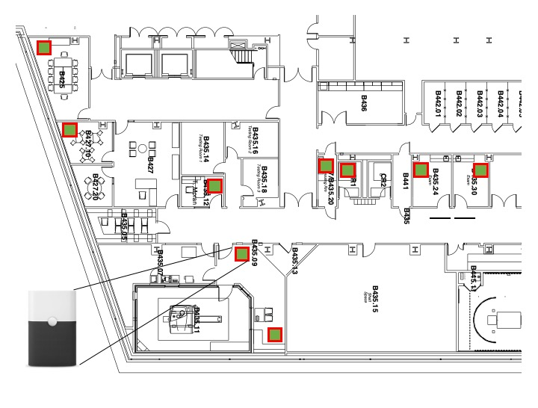

Supply airflow of the rooms to be used specifically for the neuroimaging facility are as follows, split by rooms used multiple times per day, and the rooms used only once per day by a single participant for changing (not shared occupancy). Rooms used multiple times per day:
- Room B435.11 (MRI Scanner Room):
  - Minimum supply airflow: 1,300 cfm
  - Maximum supply airflow: 1,300 cfm
- Room B435.09 (MRI Control Room):
  - Minimum supply airflow: 275 cfm
  - Maximum supply airflow: 550 cfm
- Room B435.05 (Waiting vestibule):
  - Minimum supply airflow: 175 cfm
  - Maximum supply airflow: 275 cfm
- Room B425 (Blue Zone Testing Room 1):
  - Minimum supply airflow: 225 cfm
  - Maximum supply airflow: 550 cfm
- Room B427.10 (Blue Zone Testing Room 2):
  - Minimum supply airflow: 150 cfm
  - Maximum supply airflow: 300 cfm
- Room B427.20 (Parent Waiting Room):
  - Minimum supply airflow: 100 cfm
  - Maximum supply airflow: 275 cfm
- Room B435.24 (TMS Room):
  - Minimum supply airflow: 200 cfm
  - Maximum supply airflow: 225 cfm
- Room B435.30 (Exam Room):
  - Minimum supply airflow: 200 cfm
  - Maximum supply airflow: 225 cfm

Assigned changing rooms used once per day by a single participant:
- Room B435.14 (Testing Room)
  - Minimum supply airflow: 140 cfm
  - Maximum supply airflow: 250 cfm
- Room B435.16 (Testing Room):
  - Minimum supply airflow: 125 cfm
  - Maximum supply airflow: 225 cfm
- Room B435.18 (Testing Room):
  - Minimum supply airflow: 100 cfm
  - Maximum supply airflow: 175 cfm
- Room B437 (Changing Room):
  - Minimum supply airflow: -75 cfm
  - Maximum supply airflow: -75 cfm *Has exhaust air only.
As per the University facilities guidelines, available filtered or fresh airflow should always exceed 100 cfm per person. Given this, the maximum occupancy from the ventilation perspective is 13 for the MRI scanner room and 2.75 for the control room without filtration, and greater than 5 with our redundant HEPA units. The waiting vestibule (B435.05) and parent waiting room (B427.20) will each never have more than a single person. The changing / testing rooms will be used once per day by a single person. The TMS room (B435.24) and Exam room (B435.30) air flow rates have been increased by building management to bring the minimum airflow up to a level compatible with 2 person occupancy (200 CFM). These rooms will also have supplemental ventilation through the use of fans outside the open doors to further decrease exposure during the close contact between experimenter and participant necessary during the procedures in these areas. An alternative to a fan we are exploring based on recommendation of Chiu Oan Ngooi from EH&S is to reduce the intake flow so that the room has positive pressure and pushes the airflow under the door, outside of the room, given the close contact. In either case these two critical rooms also have HEPA filters for additional protection.

Local Storage to Minimize Between-Building Travel

Many groups that use the neuroimaging facility are not themselves located within the facility. To minimize the need for groups to travel between buildings, the participant lockers will be redeployed to act as on-site storage for experimenter user groups. The participants will enter and store their belongings within their assigned rooms for the day, so there will be no overlap between participant and experimenter use of the lockers. Every other locker will be assigned to increase spacing, with each group permanently assigned their own coded lock. Assigned lockers will be clearly labeled by lab name to avoid accidental cross-contamination. User groups will be instructed to come straight to the B4 neuroimaging facility and leave campus after its use without entering their home lab buildings to avoid cross-contamination.

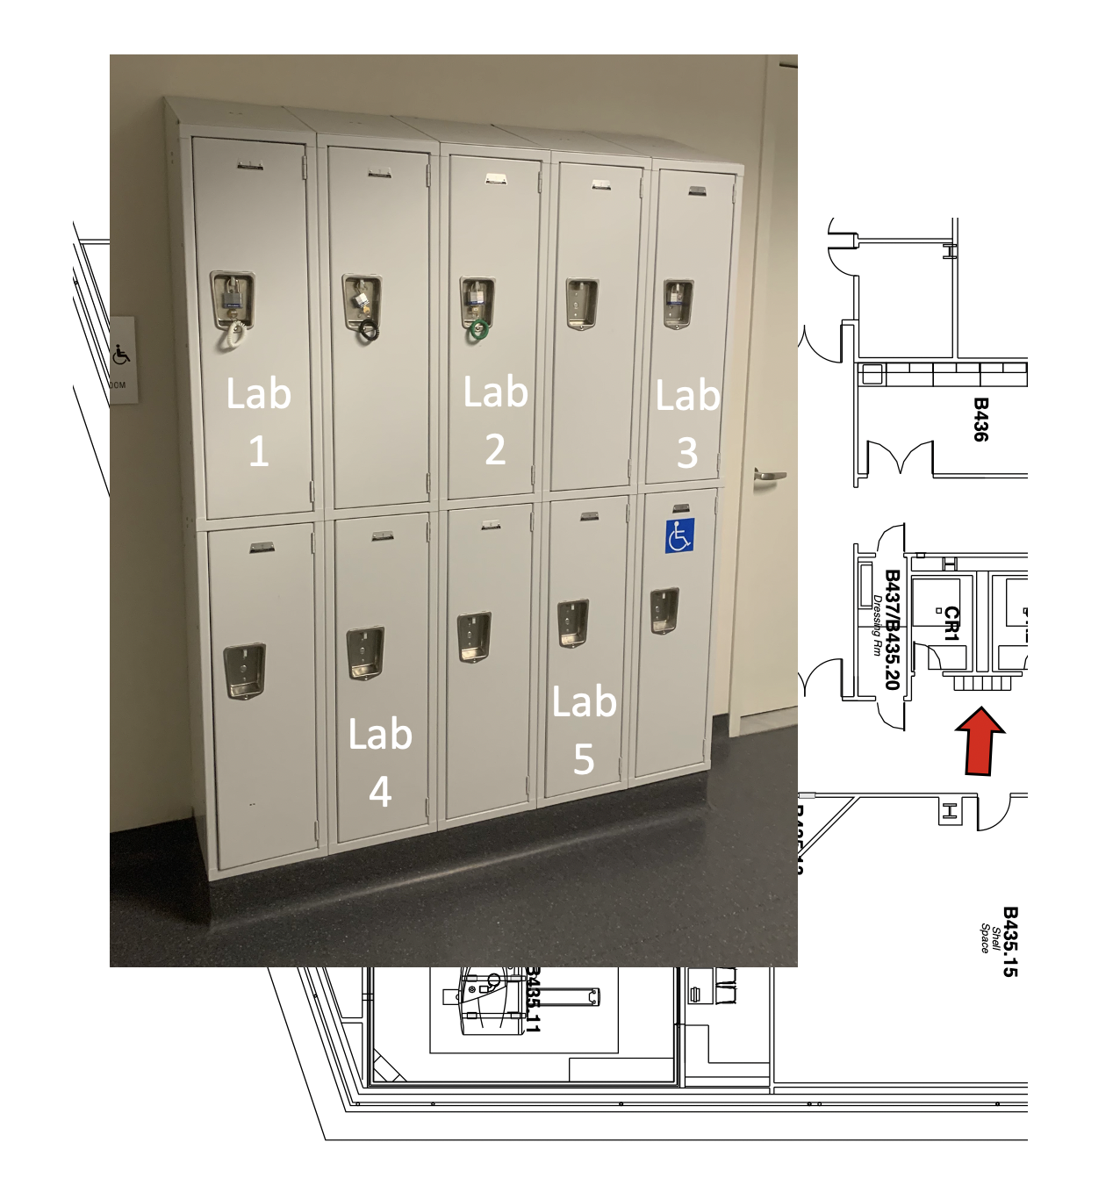

Training, Lab Support, and Maintenance
In addition to University-wide training, we will implement neuroimaging-specific virtual training of researchers on proper equipment use, cleaning and disinfecting procedures for the facility. Tammy Moran, who has developed and led our virtual MRI safety course throughout the stay-at-home period, will develop a paired COVID-19 virtual training program. This program will include images and short videos where necessary to demonstrate proper cleaning and safety techniques, and diagrams showing areas that are now disallowed and proper paths, as well as provide an opportunity to discuss the revised procedures with individuals and small team groups prior to their arrival to the facility. A buddy-system test will be implemented at an orientation on their first arrival to walk though in person (with Tammy virtual) all of the required steps and precautions. This will be done using a combination of Zoom and remote cameras we have installed already.

More general MRI training is presently paused. Typical training involves observing and assisting studies. We intend to revisit a training protocol in later phases of return to human studies research but conservatively pause them in the initial phase of reopening.

Lab support will be accomplished as much as possible through core staff members maintaining the facility at hours separate from when groups are using the facility, through virtual interactions as above, and through TeamViewer which is already up and running in the facility. Specifically, Ross Mair, the Head of MR Physics, is able to view and modify sequences at the MRI console and even run and visualize results from MRI scanning remotely.

Any maintenance issues requiring support will first be attempted virtually via TeamViewer. If in-person maintenance or troubleshooting is required, this will be completed once the facility is vacated of experimenters and participants. For issues that require immediate, brief onsite trouble shooting, if Ross Mair is in his separate office, he will come down. One of the two experimenters will exit the control room; the other will move to the behavioral area >10ft from the console, and then Ross will put on disposable gloves, enter the control room and address the issue at the console. He will dispose of the gloves, exit the room, and the second experimenter will return on his exit, in this manner low density and maximized distancing are maintained throughout the entire process.

Adherence
This SOP document will be distributed to and reviewed by all researchers accessing the neuroimaging core. Failure to adhere to the guidelines provided in the SOP will result in the immediate suspension of access to the core.

Emergency Shutdown Procedure

If an individual member of the Neuroimaging Core Facility should develop symptoms of and/or test positive for COVID-19, they should immediately self-isolate and contact Harvard University Health Services (HUHS) who will determine if and what further action should be taken.

In the case that it is deemed necessary that the Neuroimaging Core should be shutdown due to Covid-19 exposure, Tammy Moran will then coordinate with the Northwest building manager, to implement the safe shutdown plan, and all active work will be shut down. The only urgent issue is that the MRI room and MRI control room doors are locked.

Tammy Moran will coordinate with the building manager and the local safety committee to disinfect all lab areas and lab offices. They will lock all spaces and post notices at all entrances that the lab is shut down for safety reasons and no on-campus work is allowed until the end date of the isolation period. They will continue daily communication with the PI and staff and provide updates to the safety committee as frequent as they deem necessary.

At the end of the isolation period Tammy Moran and Ross Mair will coordinate the reopening of the lab. Tammy Moran will then alert users when it is appropriate to return to the facility. HUHS will provide guidance to individuals who have self-isolated as to when it is appropriate to return to campus.

Ramp Up Plan From Preparation to Staggered Implementation of Studies

This section concerns YELLOW Phase-1 (restart) and Phase 2 (active research) phases following the decision to progress to a “Low Density (YELLOW)” phase of research.

(1) YELLOW Phase-1.

Ross Mair (Head MRI physicist) and Randy Buckner (Core Director) will be the initial staff tasked with preparing aspects of the physical space including moving the MRI console and testing the operations in the new arrangement, as well as modifying the rooms as outlined in this proposal, placing floor markings, and placing signage. This will occur during week 1 of the return, with Buckner in his office (upstairs from the MRI facility) acting as a virtual buddy. They will also be tasked with verifying order shipments have arrived (which are being tracked remotely). Mair and Buckner will work physically separately except to conduct test cleaning and test experiments using the MRI scanner where Buckner will serve as test participant. In this situation, Emily Iannazzi (a safety-trained research assistant) will act as the second (safety) operator. A key aspect of this initial phase is testing the assumptions and logistics of the proposed plans, and simplifying where possible. For testing, Mair and Buckner will act as two experimenters and to test cleaning procedures, and Mair and Iannazzi will act as two experimenters and Buckner as participant.

Tammy Moran (Operations Director) will be tasked with finalizing the details of preparation and preparing participant kits for MRI scanning (including individualized PPE kits with socks, linens, etc for each participant). This preparation will be performed weekly with the idea that all PPE and materials for each subject (and spares) will be prepared in advance and be located within the four subject preparation rooms so that each subject will have ready all materials that are needed in the single room that she or he enters for the study.

Re-test of assumptions. After establishing candidate working protocols, two additional experienced experimenters (Lindsay Hanford and Lauren DiNicola) will be trained and instructed to run through cleaning and experimental procedures with Buckner acting as the participant. The idea here is to test assumptions and test whether the procedures can be instructed and implemented by additional investigators.

(1) YELLOW Phase-2.

Three NIH-funded projects have been identified as initial studies to begin the restart: (1) a study that seeks comparison of novel structural MRI sequences (PI Buckner), (2) longitudinal acquisitions on the Human Connectome Project (HCP) (PI Somerville), and (3) longitudinal acquisitions on the STAR project (PI McLaughlin). We are also exploring the feasibility of rapid restart of the study of dogs from Erin Hecht’s laboratory. The first study for restart will be that of Buckner because of its simplicity, amenability to separation of the MRI operator and second safety operator, and also because Buckner and Mair are investigators, thus allowing them to use this study to iron out any unexpected hiccups. Buckner’s laboratory has the capacity to have two fully redundant trained teams (for alternating Yellow and Blue week scanning) as well as a team in reserve. This will allow some flexibility during this critical transition.
Appendix I: List of Available PPE, Disinfectants, and Local Filtration

PPE:
Vinyl Gloves – medium 1000
Vinyl Gloves – large 1000
Latex Gloves – medium 2000
Latex Gloves – large 1000
Nitrile Gloves – medium 2500
Nitrile Gloves – large 1500

3-ply disposable masks 500
Face shields 280
Disposable Gowns 140

Disinfectants:
Clorox and Lysol wipes 50+ containers
Hand sanitizer building-supplied dispensers installed throughout
Hand sanitizer backup 60 8oz bottles as emergency backup
Disinfectant mop pads 8 boxes

Other Relevant Supplies:
Kimwipes 6 cases of 60 boxes
Saran wrap 4 boxes
Keyboard covers and mouse covers 200 each

Wastebaskets 40 (act as receptacles and, upside-down, stands for wipes)
Automated Soap dispensers 4

Non-contact thermometer 3

Local Filtration:
BlueAir 211+ Air Purifier 9 units

UVC Irradiation:
Analytik Jena UVP Crosslinker UV Irradiation System CL-3000 1 unit

