Contact Information
Principal Investigator
Conor Walsh
Tel:
Cell:
Email:

Motion Capture Lab Manager
Jonathan Foster
Tel:
Cell:
Email:

Wyss Institute Clinical Research Manager
Sarah Sullivan
Tel:
Cell:
Email:

Walsh Lab Administrator
Frey Tesfaye
Tel:
Cell:
Email:

Table of Contents

1. Overview. 3
2. Physical separation by work zones and rotating participant rooms. 4
3. Temporal separation by working groups and dissipation gaps. 7
4. Consenting 8
5. Restroom use. 8
5. Changing Room use. 9
6. Hand washing and Hands-free entry 9
7. Precautions and use of PPE for researchers and participants 9
8. Disinfecting procedures including equipment modifications. 11
9. Ventilation and local filtration. 12
10. Training, lab support, and maintenance 12
11. Adherence 12
12. Emergency lab shutdown procedures 13
13. Appendix 1: List of available PPE and disinfectants 13
14. References 14

Overview
The Harvard SEAS Motion Capture Lab (MCL) is a shared biomechanics research facility in lower level 2 (LL2) of the SEC building supporting a diverse team of researchers performing human subjects testing and engineering work. We work with many different populations, and safety of all team members and participants is paramount.
To ensure the safety of staff, participants and the public, new precautions must be taken to account for the risks associated with the COVID-19 pandemic. This will require many adjustments from the normal operations to which we are accustomed. Typical experiments involve many close interactions between participants and study team members. Special considerations relating to infection control involve advanced cleaning methods of the lab space and equipment before and after testing, additional screening of participants and team members, additional use of PPE, a decreased number of study team members, and spatial separation of participants and team members.
The COVID-19 procedures are carefully structured to minimize human interactions in time and space. Cleaning protocols have been designed with redundant controls creating a buffer in anticipation of human error. The procedures were developed within the framework of the Harvard University Research Laboratory Re-Entry Plan as well as the CDC’s Reopening Guidance for Cleaning and Disinfecting. The procedures are a foundation for safe conduct of human studies research. All investigators doing human studies research must obtain or modify their human studies (IRB) approval to accommodate the risks and disclosures of conducting research in the context of the COVID-19 pandemic.

Physical Separation by Work Zones and Rotating Participant Rooms
Separation of participants and study team members within the motion capture lab facility is maximized by strategies for the concurrent occupation of space and by rotating use of space over time. Four specific challenges are addressed: (1) Participant movement into the space, (2) Participant movement, (3) Interaction within the motion capture lab, and (4) Separation of the experimenters within the lab space while conducting research using a zone strategy. We first describe the modification of the overall space then separately describe procedures to accommodate each of the four specific challenges.
1. Overall modified use of space.
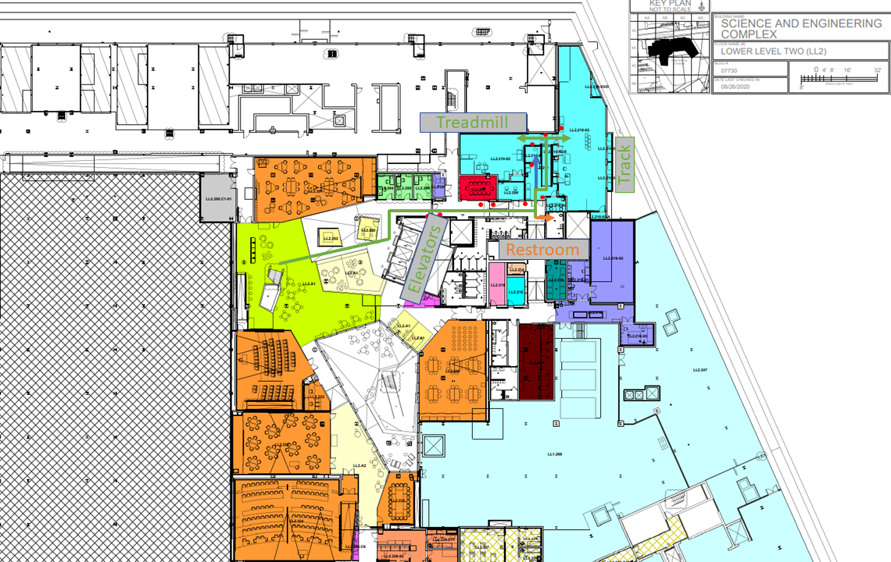
Figure 1: Participant directions to the MCL on LL2
MCL users and participants will only have access to relevant MCL testing rooms located in SEC LL2.210. Rooms that are not necessary will have their use disallowed or have signage to limit their usage. The waiting room (LL2.210) will have signage on all seats to limit use. The consenting room LL2.210-04 will not be used, and remote consent procedures will be used. Researchers and participants will complete an on-demand procedure to enter into the building (See 2 below). The path used by motion capture lab researchers and participants (Figure 1- Green Arrow) is designed to minimize areas that need to be disinfected. All doors will be opened and closed by the researchers as outlined by the “Hands-Free entry” section of this SOP. MCL participants will have a dedicated changing area within the MCL (LL2.210-01) (Figure 1- Labelled in blue). Detailed instructions for the participant changing room are provided in the “Changing Room Use” section of this SOP. For participants and researchers, it will be recommended to make use of the nearest restroom to the MCL (Figure 1- Orange Arrow). Detailed instructions for the participant restroom are provided in the “Restroom Use” section of this SOP.
2. Participant movement into the space.
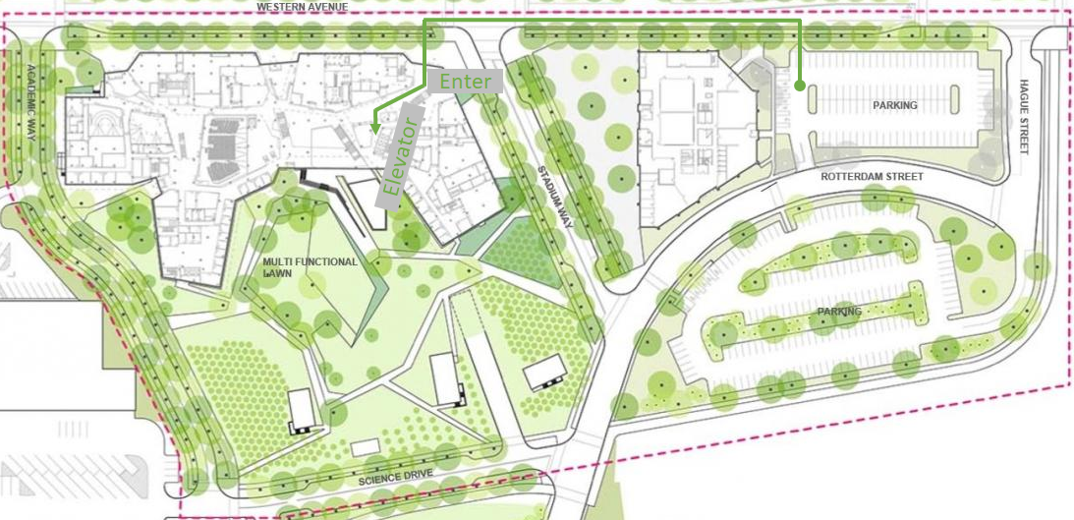
Figure 2: Participant directions to the main entrance of the SEC
Participants will consent remotely to the study before entering the SEC for HSR. Participants will be contacted via phone, text, or email and met at the main SEC building entrance (Figure 2). Before entering the building, the participant will be issued an appropriate mask, a study team member will check the participant’s temperature (using a no-contact IR thermometer) and perform the pre-screening questionnaire (Crimson clear or this link to download screening procedures for non-Harvard affiliated participants). If the participant’s unwilling to wear a mask, has a temperature of 100.4 ℉ or above (CDC fever definition), or answers “Yes” to any condition in the Pre-screening questionnaire, we will not proceed with testing. Once these steps are completed, the study team member and participant will enter the SEC building. They will take the stairs (preferred) or main elevator down to LL2. The participant will be escorted at a safe distance (following the green path [Figure 1]) through the first set of doors, then through the double doors and into the MCL waiting room (LL2.210). Signage will be placed throughout the SEC building to direct researchers and participants to the MCL and restrooms. For daily MCL capacity will be no more than the recommended occupancy (9 and 4 for the track [LL2.210-03] and treadmill [LL2.210-02] rooms, respectively) at one time. Participant’s testing sessions within a particular MCL room will be separated by an aerosol dissipation gap of at least 30 minutes.
Participants who choose to drive the study visit will be directed to the 114 Westren Avenue Parking lot. Participants will be provided instructions to walk towards the main entrance via Western Avenue and follow the standard building entry protocol outlined above.
3. Participant and researcher interactions.
The researchers and participants will wear masks at all times during research studies performed in the MCL, with the exception of respirometry testing, in which the participant will wear a respirometry mask and anti-bacterial/anti-viral filter in place of a surgical mask. Both researchers and participants will wash their hands prior to the start of the experiment at the hand wash stations located within either the track or treadmill lab of the MCL. The researcher will also wear additional PPE when in close contact (less than 6 feet apart) with the participant. Guidance for appropriate PPE is outlined in the precautions and use of PPE for researchers and participants section. Examples of such instances of close contact include but are not limited to: motion capture marker placement, EMG sensor placement, exosuit donning and doffing, measuring vital signs, and anthropometric measures. To minimize contact time, all necessary materials and sensors will be pre-positioned on a rolling table during pre-cleaning. The researcher will dispose of gloves and sanitize their hands following making close contact with the participant.
4. Separation of the experimenters using a zone control room strategy and reduced team sizes.
To ensure social distancing procedures are followed, zones will be created on a study by study basis in the MCL’s track (LL2.210-03) and treadmill (LL2.210-02) labs. These zones will be marked by tape on the floor, labelled with study name, and have buffer zones between them. For research studies involving walking around the track in MCL room LL2.210-03 (track room), a 6’ radius will not be possible when the participant is walking past the control desks. In these instances, a plastic desktop shield or face shield can be utilized to minimize the risk of exposure. Two examples of a zoned approach, with 2 study team members (#) and 1 participant (p) are provided below.

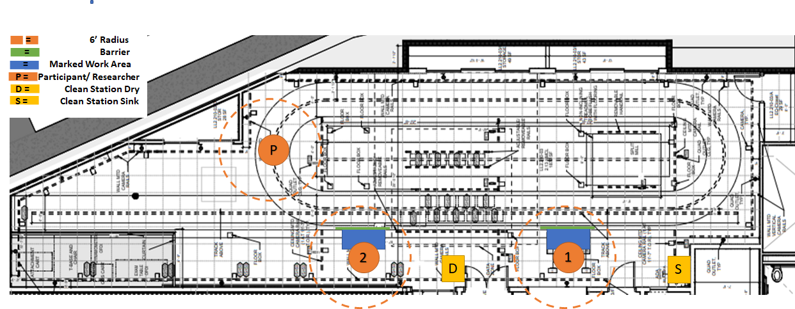
Figure 3: Example setup for the Track Lab
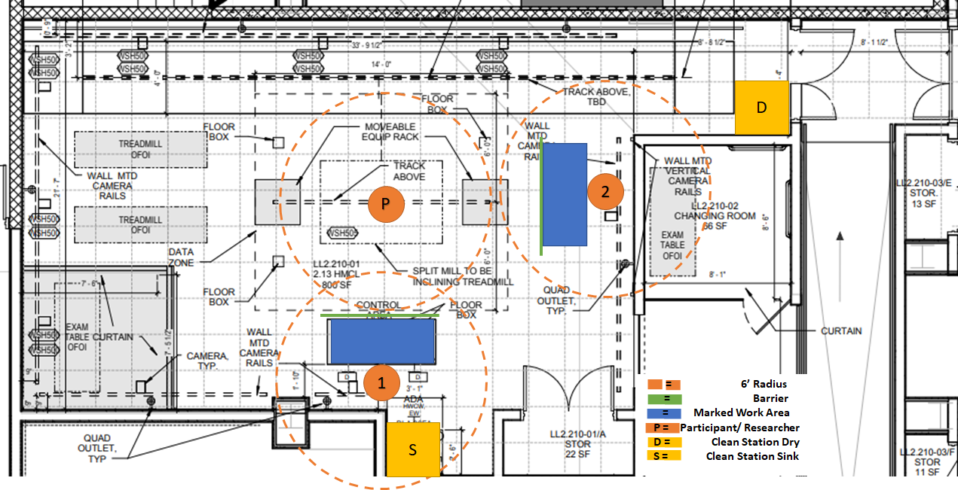
Figure 4: Example setup for the Treadmill Lab

Temporal Separation and Dissipation Gaps
Booking for the rooms will be performed using an online calendar. Lab space will be booked on a first come first-served basis, at least 24 hours in advanced. Research teams booking either the Track or Treadmill lab must schedule and strictly adhere to a time within the particular lab space. Research teams will be informed that they must block a mandatory 30-minute aerosol dissipation gap before and after their scheduled testing time. The MCL manager will monitor the calendar to ensure dissipation gaps are in place. All research teams must complete an online spread-sheet for contact tracing purposes to track activity within the MCL. This spread-sheet will include who was in the lab, what time they entered, and what time they left. The MCL manager will utilize this document to notify individuals who might need to self-isolate (point 3 below).
1. Aerosol Dissipation Gaps.
A 30-minute gap is imposed between research groups or researchers using a MCL lab on the same day. Using the online calendar and a sign-up system will ensure two separate lab working groups or researchers never encounter one another. This system will also guarantee proper aerosol dissipation before the arrival of the next research group or researcher.
2. Flexibility and Acceptable Variations.
Although rules between researchers and research groups are accounted for, a potential situation where a single research group intends to use the same lab space but change, e.g. use a different participant. In this situation, the group will need to disinfect the entire lab between participants and allow for/ schedule an aerosol dissipation gap between each participant. The fundamental principle is that separate lab groups, researchers, or participants should not follow one another without an Aerosol Dissipation Gap between them.
3. Limiting the Consequences of an Infection.
If an individual displays symptoms or tests positive for COVID-19, they will be required to notify their PI and the MCL manager immediately. All individuals who were in the facility at the same time or entered after the individual on the same day may be asked to self-isolate and avoid returning to the facility for up to two weeks.

Consenting
Remote consent procedures will be used for MCL participants.

Restroom Use
The LL2 has a single-occupancy restroom within it (Figure 1- labelled blue), requiring card access. This restroom will be recommended for participants. The researcher will escort the participant to the restroom to provide access and return to the laboratory. While it is recommended that participants and researchers wash their hands upon using the restroom, they will be asked to do so upon returning to the MCL (see “Hand-Washing”). The use of a recommended restroom will create a controlled setting where it is known what restroom was used for contact tracing purposes.

Changing Room Use
LL2.210-01 is a single-occupancy changing room located within the MCL (66sq ft, 40cfm with a CLOCC occupancy of 1). The changing room will be reserved for participants.. For the participants convenience, disinfectants will be located on a table in the changing room. To minimize touching contact points, and to promote aerosol dissipation the door to the changing room will be left open, unless occupied by a participant. Kimwipes will be positioned by the entrance/ exit of the changing room consistent with the Hands-Free Entry Policy. Alternatively, both the Track and Treadmill lab have a curtained off area that the participant can use for changing clothing.

Hand Washing
Frequent hand washing is a requirement. Researchers will wash their hands when using the external restroom, when entering the MCL, when exiting the MCL, and critically, before leaving to meet participants and upon returning to the MCL. Frequent handwashing is advised. Both MCL labs (track and treadmill) will have two cleaning stations. The cleaning station with a sink (Figure 3 & 4) has soap and paper towel dispensers installed on the counter and wall next to the sink. A second cleaning station, without a sink, will be located near the entrance/ exit of the MCL labs containing disinfectants including hand sanitizer (Appendix 1). We ask that participants and researchers wash their hands when using the restroom, and upon entering and exiting the lab.

Hands-Free Entry
Door handles at entryways and closets represent a potential source of contamination. At each used location, on both sides of entryways, single-use one-at-a-time dispensing Kimwipes will be available to take before touching the handle and a waste receptacle will be positioned to receive the used wipe. Figure 1 red dots indicate where Kimwipes (on stands) and waste receptacles will be located (the economical stands will simply be upside-down 20” plastic waste receptacles). Each to-be-used waste receptacle will be labeled “Wipe Disposal Only!”. When escorting participants through the space, researchers should offer to open and hold doors for participants. Participants will be informed to use Hands-Free Entry for the use of the restroom or change room. This will further reduce transmission risk to the participant or study team members.

Precautions and Use of PPE for Researchers and Participants
1. Mode of transmission of Covid-19

It is important to understand the mode of transmission of Covid-19, as it will guide the understanding of its associated precautions, and may support decision-making on the use of PPE. Per CDC, the mode of transmission happens mainly through person-to-person transmission during close proximity contact through the following:
Respiratory droplets: These are produced through talking, coughing, or sneezing. When in close proximity, these droplets can land on another person’s mouth, eyes, or nose, and can also be inhaled into lungs.
Contact: Touching contaminated surfaces followed by self-delivery to eyes, nose, or mouth may cause infection. This is not the primary mode of how the virus spreads, however this may be a possible mode of transmission. Ongoing studies are examining this. (check for updates: https://www.cdc.gov/coronavirus/2019-ncov/prevent-getting-sick/how-covid-spreads.html)

2. Precautions

Screening prior to and upon entry to lab: To help prevent the spread of disease, participants and researchers will undergo a screen prior to study visits to identify any self-reported symptoms or factors such as travel history that are relevant to risk-assessment of Covid-19. An answer of “Yes” in Pre-screening questionnaire (Crimson clear or the following link) or fever as defined by CDC deems researcher or participant not suitable for testing on that day.

Standard Precautions serve as the primary strategy for preventing transmission of infection in healthcare settings¹. It is the minimum infection prevention practice that is observed regardless of the status of infection of the patient¹.
- Adhere to Standard Precautions to ALL participants, including those who are not known or suspected to have Covid-19. For those who are known or suspected with Covid-19, follow Standard Precautions and Transmission-based Precautions².
  - Transmission-based Precautions refer to Droplet Precaution and Contact Precaution procedures. Because our research setting is not directly involved with participants with suspected or known Covid-19 infections, these procedures may not be particularly applicable to MCL-related procedures. However, in the unforeseen event of contact with someone with suspected or known Covid-19 infection, please follow both Standard Precautions and Transmission-based Precautions and contact Health Services.

3. Elements of Standard Precautions³ (language modified for MCL research settings):

All researchers and participants will follow standard Harvard and CDC guidelines when operating in the MCL. Standard procedures will include recommendations to perform frequent hand hygiene³ , use PPE (facemasks) within the MCL, maintain respiratory hygiene and cough etiquette³, and use environmental control measures³ to sanitize laboratory equipment and surfaces.

The principle method to reduce transmission will occur through reduce close contact. Researchers and the participant will reduce close contact interactions during study visits. Studies will be piloted to determine effective participant placement³ to reduce close contact, defined as the interaction that happens in close proximity of < 6 feet.

Close contact interactions may not be entirely avoidable in human subject testing due to logistical and safety (e.g. need to guard to prevent falls) considerations. As such, close contact interactions will be limited to a single researcher. However, in specific events when participant risk for harm is high, such as falls or losses of balance, a second researcher may be needed to work in close proximity to mitigate risk. If close contact is necessary, researchers will be expected to use additional hand hygiene (cleaning before and after participant contact or donning gloves) and PPE (ie. face shields and gloves). Researchers will be trained to observe proper sequence in donning and doffing of PPE⁵.

Disinfecting Procedures Including Equipment Modifications
Disinfecting procedures will closely follow CDC reopening guidance. The disinfecting procedures have two components – (1) procedures conducted on entering and exiting a lab, and (2) procedures that take place between participants.
(1) Disinfecting procedures entering and exiting a lab.
On entry into the facility and as the last act before leaving the facility each study team will disinfect (a) accessible knobs, handles, faucets, handrails, phones, and the participant restroom, (b) equipment such as treadmill controls, handrails, EMG sensors, motion capture markers, metabolic testing components, exam tables, peripheral equipment, and (c) investigator-used work surfaces including desks, tables, keyboards and mice. Having cleaning conducted both on entry and exit of a lab creates redundancy in disinfection between testing blocks given real-world imperfections and the multiple surfaces.
CDC-approved Clorox and Lysol disinfectant wipes and sprays and paper towels are available in all rooms at the indicated cleaning stations (Figures 3 & 4). There are also hands-free Purell stations in multiple strategic locations throughout the facility. A high-level OPA disinfectant, located at the sink cleaning station, will be regularly checked and renewed for the cleaning of Cosmed metabolic testing components. Researchers will wear the provided latex or vinyl gloves and face masks at all times while cleaning, disinfecting, and when handling trash.
Trash bins will be placed in each room for disposal of wipes, paper towels, Kimwipes, gloves and gowns. Trash bins will be put out into the hallway at the end of the day for removal by custodial staff.
After cleaning procedures (and as often as needed during cleaning) and/or putting trash bins out into the hall, gloves and gown will be removed carefully to avoid contamination of the wearer and the surrounding area, and disposed of in designated trash bins. Immediately after removing gloves, the researcher will wash their hands with soap and water in the hand-washing area.
(2) Disinfecting procedures between participants.
Between individual participants, the full set of procedures indicated above will be repeated, excluding cleaning of investigator-used work surfaces (category c, above)
(3) Equipment Modifications.
Hands-free Purell and soap dispensers will be installed throughout the facility. Any unnecessary keyboards, mice, and equipment and furniture will be removed when possible. Specific SOP have been developed for cleaning and storing of motion capture markers, EMG, cosmed, ultrasound and exosuit disinfection, as indicated below.

Refer following links for detailed device-specific procedures:
Device Specific SOP: Motion Capture
Device Specific SOP: EMG
Device Specific SOP: Respirometry and Spirometry
Device Specific SOP: Ultrasound Imaging
Device Specific SOP: Wearable Robots and Textiles

Ventilation and Local Filtration
Supply airflow of the two rooms in the motion capture lab is as follows:
- Room LL2.210-03 (Track Lab):
  - Size: 1863 sq ft
  - Airflow: 2250 cfm
  - CLOCC max occupancy: 9 Individuals
- Room LL2.210-02 (Treadmill Lab):
  - Size: 788 sq ft
  - Airflow: 1275 cfm
  - CLOCC max occupancy: 4 Individuals
As per the University facilities guidelines, available filtered or fresh airflow should always exceed 100 cfm per person, and floor space should exceed 200 sq ft per person. Given this, the CLOCC maximum occupancy is 9 for the track lab and 4 for the treadmill lab, and we will make sure this is obligated at all times, including participants and research team members.
Inhalation of infected droplets and aerosols present risk for infection. In addition to wearing face masks, maximizing distances between individuals, implementing temporal gaps between investigator groups, and screening all individuals for symptoms of infection, another way to mitigate risk is local air filtration with a top-emitting air purifier with a HEPA filter. Both labs are considered highly ventilated with air flow exceeding 100 cfm per person allowing for a 30 minute aerosol gap. However, we have a HEPA filter in the MCL we can use to increase the filtration for activities like treadmill running.

Training, Lab Support, and Maintenance
When possible, we will implement virtual training of researchers on proper equipment use. This will be done using a combination of Zoom and Team Viewer. When virtual training is not possible and in-person training is required, the MCL will be reserved for training, proper PPE will be worn, and social distancing guidelines will be used. Any maintenance issues requiring the support will first be attempted virtually. If in-person maintenance or troubleshooting is required, this will be completed once the MCL is no longer in use.
Adherence
This SOP document will be distributed to and reviewed by all researchers accessing the MCL. Failure to adhere to the SOP guidelines will result in the immediate suspension of access to the MCL.

Emergency Lab Shutdown Procedure
If a user of the Motion Capture Lab should test positive for COVID-19, they will immediately be contacted by HUHS and their PI (who will also alert the Motion Capture Lab Manager) and advised to immediately self-isolate. With PI and Motion Capture Lab Manager, SEAS will determine when they were last in the building and if any cleaning/disinfecting is required. If necessary, the PI and Motion Capture Lab Manager will communicate with users not to use any spaces until cleaning occurs. The PI and Motion Capture Lab Manager will communicate to users when it is ok to return to the facilities.

Appendix I: List of Available PPE and Disinfectants
PPE:
- Nitrile Gloves (sizes small, medium, large)
- Surgical Grade Masks (provided by university)
- Face Shields
- Disposable Gowns
Disinfectants:
- Lysol Disinfectant Spray
- Lysol Disinfectant Wipes
- Clorox Disinfecting Wipes
- Super Sani-Cloth Germicidal Disposable Wipe
- ASP Cidex OPA Solution
- Webcol Alcohol Prep Pads
Other Relevant Supplies:
- Hand Sanitizer
- Paper Towels
- Kim Wipes
- IR Thermometer
Local Filtration:
- Blueair Blue Pure 211 Air Purifier
References
1. Centers for Disease Control and Prevention, National Center for Emerging and Zoonotic Infectious Diseases (NCEZID) D of HQP (DHQP). III. Precautions to Prevent Transmission of Infectious Agents. CDC. https://www.cdc.gov/infectioncontrol/guidelines/isolation/precautions.html.
2. National Center for Immunization and Respiratory Diseases (NCIRD) D of VD. Interim Infection Prevention and Control Recommendations for Patients with Suspected or Confirmed Coronavirus Disease 2019 (COVID-19) in Healthcare Settings. CDC. https://www.cdc.gov/coronavirus/2019-ncov/hcp/infection-control-recommendations.html. Published 2020. Accessed May 24, 2020.
3. Centers for Disease Control and Prevention, National Center for Emerging and Zoonotic Infectious Diseases (NCEZID) D of HQP (DHQP). Recommendations for Application of Standard Precautions for the Care of All Patients in All Healthcare Settings. CDC. https://www.cdc.gov/infectioncontrol/guidelines/isolation/appendix/standard-precautions.html%0D. Published 2015. Accessed May 24, 2020.
4. Kelley ED. Comprehensive Personal Protective Equipment (PPE) Guidance. USA: The Commonwealth of Massachusetts Executive Office of Health and Human Services Department of Public Health Bureau of Health Care Safety and Quality; 2020:1-4.
5. CDC. Sequence for Putting on Personal Protective Equipment. CDC. 2018:1-3. doi:10.1891/9780826144225.ap03
6. National Center for Immunization and Respiratory Diseases (NCIRD) D of VD. People Who Are at Higher Risk for Severe Illness. CDC. https://www.cdc.gov/coronavirus/2019-ncov/need-extra-precautions/people-at-higher-risk.html. Accessed May 26, 2020

