Contact Information
Principal Investigator
Conor Walsh
[Email]

Wyss Institute Associate Clinical Research Manager
Lauren Bizarro
Tel: XXX-XXX-XXX
[Email]

Walsh Lab Administrator
Frey Tesfaye
Tel: XXX-XXX-XXX
[Email]

Table of Contents
- Overview
- Testing Location & Traveling to Visits
- Restroom Use
- Patient Populations
- Screening
- Physical separation of participants and researchers
- Disinfecting Procedures
- Emergency Procedures In Case of Transmission
- Appendix I: List of Available PPE and Disinfectants

Overview
Much of our human subjects testing traditionally occurs in research facilities such as the Wyss Institute and Harvard SEAS Motion Capture Lab (MCL). However, several of our IRB protocols are approved for outdoor testing which prior to COVID-19 we had frequently performed with both healthy and clinical populations. Outdoor testing near a participant’s home could reduce several risk factors related to the exposure of COVID-19 relative to testing in the MCL including (a) reduced risk of transmission during travel to/from study visits by testing at locations within walking distance of a participant’s home, (b) elimination of risk of transmission from surfaces/other personnel within research facilities, and (c) reduced risk of transmission due to improved air circulation outdoors.
To ensure the safety of staff and research participants during outdoor testing with patient populations (i.e. stroke survivors, individuals with Parkinson’s Disease), new precautions must be taken to properly account for the risks associated with the COVID-19 pandemic. This will require many adjustments from the normal operations to which we are accustomed. Typical experiments involve many close interactions (< 6 feet) between participants and study team members. Special considerations related to infection control include advanced cleaning methods of the equipment before and after testing, additional health screening of participants and team members, additional use of personal protective equipment (PPE), and spatial separation of participants and team members.
The updated testing procedures due to COVID-19 are carefully structured to minimize human interactions in time and space, and to create buffers and redundant controls to anticipate human error. The procedures were developed within the framework of the Harvard University Research Laboratory Re-Entry Plan as well as the CDC’s Reopening Guidance for Cleaning and Disinfecting. The procedures are a foundation for safe conduct of human studies research. All investigators conducting human studies research must obtain or modify their own human studies (IRB) approval to accommodate the risks and disclosures of conducting research in the context of the COVID-19 pandemic. In addition, all testing procedures must still adhere to your project’s IRB approved protocol and standard operating procedure (SOP) for outdoor testing.

Testing Location & Traveling to Visits
Outdoor testing locations will be selected following the standard operating procedures that were already IRB approved and implemented for outdoor testing prior to COVID-19. In addition to the previous standard operating procedures, we will select locations which minimize the travel required of patient populations. Potential outdoor locations include but are not limited to: public parks, public tracks/fields, and neighborhood sidewalks near participants’ homes.
Locations will be selected that only require participants to travel by foot or private car. Locations that require rideshare or public transportation will not be used. If traveling by foot, participants’ travel will be limited to short walks from their home. If participants or members of their household own and operate a private car, short drives to nearby parks/tracks with public parking will also be allowed (parking vouchers/reimbursement will be provided).
Attendance of caregivers will be restricted, except when their presence is essential for health care, research-related decisions, or to provide support to the individual. If caregivers do attend, they will be given a mask, screened at the start of the visit, and asked to remain 6 feet away from all researchers throughout the duration of the test and encouraged to only interact with the participant if required.
In future stages of the re-opening process, these restrictions on the location of outdoor testing may be revisited but for initial resumption we have elected to take a conservative approach.
Testing locations will be limited to outdoor areas where researchers and participants can easily adhere to strict social distancing measures, i.e. remaining 6 feet away from other pedestrians. If during a visit, researchers find that due to public overcrowding strict social distancing measures cannot be adhered to, the testing session will be ended immediately.
As an example, Cavanaugh Stadium, a large public track in Quincy, MA may be used as a testing location with visits scheduled in the early morning when there is very low pedestrian traffic.
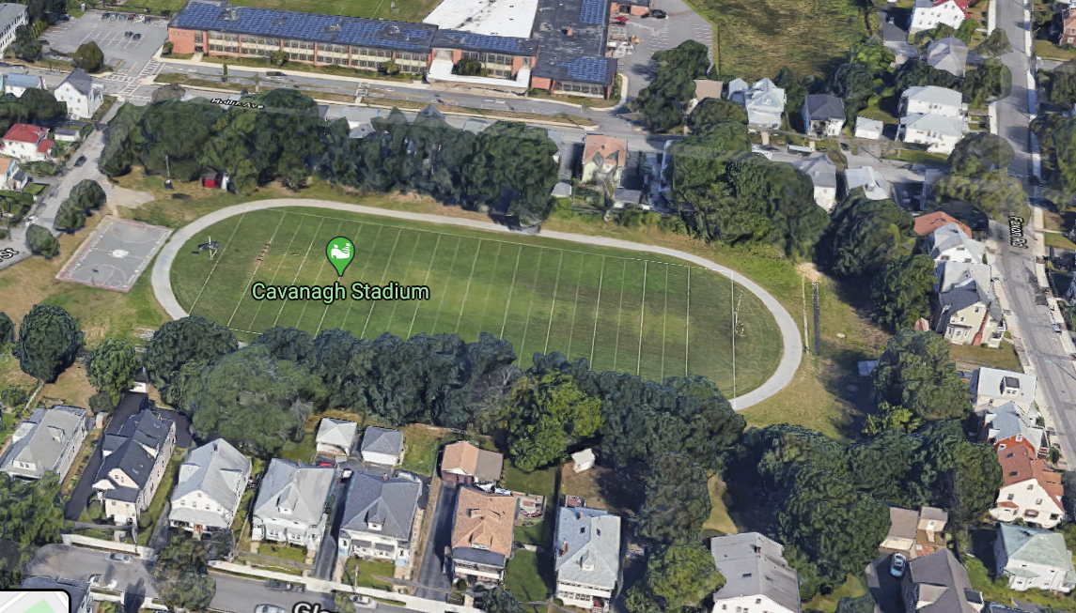
To minimize contact between researchers, all researchers will transport themselves whenever possible (via foot, bike, or private car) to the outdoor testing location. All researchers are expected to wear a mask while traveling and adhere to strict social distancing measures. If driving is required and not all researchers have access to private cars, researchers may ride in the back of another researcher's car (preferred) or use rideshare services/rental car as last resort, while wearing a face mask with windows down if it is not raining, following standard precautions throughout the trip, and washing/sanitizing their hands immediately before and after travel.
Additionally, sealable containers will be used for transporting devices and other testing materials. After testing, all materials are cleaned and packed in sealed containers and brought back to a designated space (Northwest B435.4) for handling and secondary cleaning. If applicable, cleaning of any respirometry equipment will take place in the MCL treadmill room (Northwest B445.20). See Disinfecting Procedures section for more information.

Restroom Use
If testing in close proximity to a participant’s home, only participants will be able to use the restroom within their home during a session. Participants will be instructed to sanitize their hands before entering and after leaving their home.
If testing occurs in a location where a public restroom is available, such as a public park, participants and researchers will be allowed to use the restroom at their discretion. In addition to normal handwashing procedures, any researcher or participant who uses a public restroom will be asked to sanitize their hands before entering and after leaving the restroom.

Patient Populations
One of the prominent areas of research in our laboratory is on the development of wearable robots to augment motor performance in patient populations. We design wearable robots for use in people with neurological impairments resulting from a stroke, Parkinson’s disease, or Multiple Sclerosis, as examples, to assist arm and leg functions during activities of daily living and walking. Often, participants with neurological impairment require a certain degree of supervision and assistance due to neuromotor deficits that affect their mobility, walking stability, and overall balance. As such, the IRB requires that a clinician researcher (e.g. physical or occupational therapist) is present during these visits to provide skilled guidance on these activities. Consistent with clinical practice, these participants may require some degree of close physical guarding, depending on ability, to ensure patient safety and to minimize risks for tripping and falling. In our extensive testing with patient populations over the last six years of this project, guarding clinicians have prevented multiple falls by being within close range to catch participants during walking. Thus, to maximize the overall safety of a participant, guarding from <6 feet during walking activities will be necessary for some participants (~50%). To minimize this required interaction between the clinician and participant as much as possible, we will only bring in participants who are able to accomplish mobility and daily activities without need for considerable physical assistance from another person (i.e. participants that require contact guard or less assistance).

Screening
As per Harvard, general guidance on Human Subjects Research non-Harvard affiliated participants will undergo a phone screening prior to the study visit and immediately upon their arrival at the test site using the Wyss Coronavirus Pre-Visit Screening Form that is based on daily attestation questions on Crimson Clear and CUHS approved template. Additionally, screening for fever as defined as 100.4℉ or above will be performed on non-Harvard affiliated participants immediately upon their arrival using a contactless infrared thermometer. Should a caregiver who does not live with the participant also attend the visit they too will be screened at the start of the visit and tested for a fever. A participant or caregiver’s answer of “Yes” in the Pre-screening questionnaire or the detection of a fever deems the participant not suitable for testing on that day and the study visit will be terminated.

Similar to non-Harvard affiliated participants, on the day of the visit, researchers and Harvard affiliated participants complete the Crimson Clear survey to deem them eligible for testing and will be screened for fever immediately upon their arrival using a contactless infrared thermometer. Researchers or Harvard-affiliated participants who fail to pass Crimson Clear or whose temperature is above 100.4℉ will be deemed not suitable for testing on that day.

Following general guidelines, all researchers and Harvard-affiliated participants will also monitor their own symptoms after visits, continue to complete Crimson Clear prior to use of Harvard facilities, and contact Harvard University Health Services should any symptoms arise.

Physical Separation of Participants and Researchers
Throughout the testing session, researchers and participants will aim to remain 6 feet or more from one another. However due to the nature of human subjects testing, certain activities will require closer contact (i.e. suit donning, sensor placement, physiological monitoring and guarding during walking). Physical separation of participants and study team members during outdoor testing can be broken down into five sections: 1) Participant arrival, 2) Required close participant and researcher interactions (< 6 feet), 3) Walking activities, 4) Seated activities, and 5) Participant departure..
1. Participant Arrival
Participants will be contacted via phone, text, or email and met at the agreed upon outdoor location by the clinician and will be issued an appropriate mask. Upon arrival at the outdoor study visit, participants and caregivers will be screened. See Screening section above for more details on all screening procedures.
2. Required close participant and researcher interactions (< 6 feet)
The researchers and the participant will wear masks at all times during research. Researchers and the participant will disinfect their hands using provided hand sanitizer prior to the start of the experiment. In addition, the researcher will wear a plastic face shield when close contact with the participant is required. Close contact is defined as the interaction that happens within 6 feet. Examples of such instances of close contact include but are not limited to: sensor placement, device donning and doffing, supervision guarding by a therapist, and measuring vital signs. To minimize contact time, all necessary materials and sensors will be pre-positioned during session preparation prior to participants arrival. The researcher will sanitize their hands after close contact with the participant is complete. We will also minimize the number of researchers that are in close contact with the participant. Every effort will be made to limit close contact interactions to a single researcher. However, in specific events when participant risk for harm is high, such as falls or losses of balance, a second researcher may be needed to work in close proximity to ensure participant safety.
3. Walking activities
If the protocol requires walking activities, all research team members will remain more than 6 feet away from participants during walking. In certain circumstances, when the clinician deems close guarding as necessary and consistent with clinical practice, they may guard the participant from <6 feet for safety to mitigate trips and falls (i.e. walk closely behind or to the side of the person so they can be ready to support them if needed). These instances of close contact will be limited as much is safely possible but we do anticipant they will be required for approximately 50% of participants. This required guarding during walking is consistent with clinical practice and with the current procedures implemented at local clinics such as Spaulding Rehabilitation Hospital. The clinician guarding the participant will wear increased PPE (face shield and ASTM rated facemask) and guard the participant from the farthest distance they deem safe.
4. Seated activities
During seated activities, unless a need arises (suit adjustment, physiological monitoring etc.) researchers will remain at least 6 feet away from participants. To avoid the use of public seating, a portable and wipeable chair such as a wheelchair (and table if required) will be brought to all visits for participants to use throughout the session. Like all other equipment, this furniture will be sanitized before and after each test.
Should a participant need to temporarily remove their mask, such as to have a drink of water or snack, all researchers will remain at least 6 feet away from the participant while unmasked.
5. Participant departure
Upon completion of the session, participants will be asked to sanitize their hands before departing.

Disinfecting Procedures
Disinfecting procedures will closely follow CDC reopening guidance (www.cdc.gov/coronavirus/2019-ncov/community/reopen-guidance.html). During all cleaning, study team members will wear latex or vinyl gloves and face masks per CDC recommendation.
      - Disinfecting Equipment & Handling Trash
To anticipate human error, redundant cleaning of all equipment will occur. All research equipment (folding chair, AED, first aid kit etc.) will be cleaned before and after each visit. See Device Specific SOPs in Supporting Documentation for details on disinfecting and handling of specific lab equipment including Wearables; EMG; and Respirometry and Spirometry.
Trash bags will be brought to the testing session for disposal of wipes, paper towels, and gloves. Trash will be brought back to Harvard and left outside Room B435.4 for proper disposal. Researchers will wear the provided latex or vinyl gloves and face masks at all times while cleaning, disinfecting, and when handling trash.
      - Use of Northwest B435.4 and B445.2
Lab equipment, PPE, and cleaning supplies used for outdoor testing will be located in Northwest Building Room B435.4 which will be exclusively used for outdoor testing preparation and cleanup. Before and after each visit, one designated researcher will access B435.4 to clean and pack all equipment. Outdoor testing will be scheduled such that there is a sufficient aerosol gap between each use of Room B435.4.
On entry into the facility and as the last act before leaving the facility, each study team will be responsible for disinfecting all accessible knobs, handles, and surfaces. Having cleaning conducted both on entry and exit of a use block creates redundancy in disinfection between blocks given real-world imperfections and the multiple surfaces. EPA-approved Clorox and Lysol disinfectant wipes and sprays and paper towels as well as hand sanitizer are available in the room.
If the protocol involves the use of Cosmed metabolic testing equipment, the same designated researcher will use room B445.2 for the cleaning of Cosmed. A high level OPA disinfectant will be regularly checked and renewed for the cleaning of Cosmed metabolic testing components. Researchers will wear the provided latex or vinyl gloves and face masks at all times while cleaning, disinfecting, and when handling trash.
Trash bins will be placed in each room for disposal of wipes, paper towels, Kimwipes, and gloves. Trash bins will be put out into the hallway at the end of the day for removal by custodial staff. After cleaning procedures and/or putting trash bins out into the hall (and as often as needed during cleaning), researchers will wash/sanitize their hands.

Emergency Procedures In Case of Transmission
If a research team member should develop symptoms of and/or test positive for COVID-19, they should immediately self-isolate and contact Harvard University Health Services (HUHS) who will determine if and what further action should be taken.

Appendix I: List of Available PPE and Disinfectants
PPE:
- Nitrile Gloves (sizes small, medium, large)
- Surgical Grade Masks (provided by university)
- Face Shields
- Disposable Gowns
Disinfectants:
- Lysol Disinfectant Spray
- Lysol Disinfectant Wipes
- Clorox Disinfecting Wipes
- Super Sani-Cloth Germicidal Disposable Wipe
- ASP Cidex OPA Solution
- Webcol Alcohol Prep Pads
Other Relevant Supplies:
- Hand Sanitizer
- Paper Towels
- Kim Wipes
- IR Thermometer

