[YOUR FACILITY NAME] COVID-19 Operating Procedures

Version 0.0: Jun 01, 2020

Contact Information:

Title:
Name:
Cell:
Email:

Title:
Name:
Cell:
Email:

Title:
Name:
Cell:
Email:

Title:
Name:
Cell:
Email:

Table of Contents
[Add or modify sections depending on the specific facility. Potential sections to be added include hands-free entry instruction, local storage to minimize travel, training, lab support, and maintenance, Emergency lab shutdown procedures, alternative schedule options etc.]
[Restroom usage plan can be added as an optional section. Note that individual groups can make informal plans on nearby restrooms and coordinate among themselves, but it is not allowed to label the restrooms or exclude others from using them.]

1. Overview. 0

2. Physical separation. 0

3. Temporal separation. 0

4. Hand washing stations. 0

5. Precautions and PPE for researchers and participants. 0

6. Disinfecting procedures. 0

7. Ventilation and local filtration. 0

8. Appendix I: List of available PPE, disinfectants, and local filtration. 0

- Overview

[Give a brief overview of the testing location. If there are specific issues to consider for the facility, please add here.]

- Physical Separation

[Add plans for physical separation. This may include different working zones for investigators, different paths for participants and spaces for changing, separation between the investigators’ space and the participant’s space etc. If there are plans for purchasing more equipment and/or tools for better physical separation, they can be added here.]
[Floor plans with labels of different working zones, paths, and spaces are highly desired. Below is an example from CBS Neuroimaging Lab.]

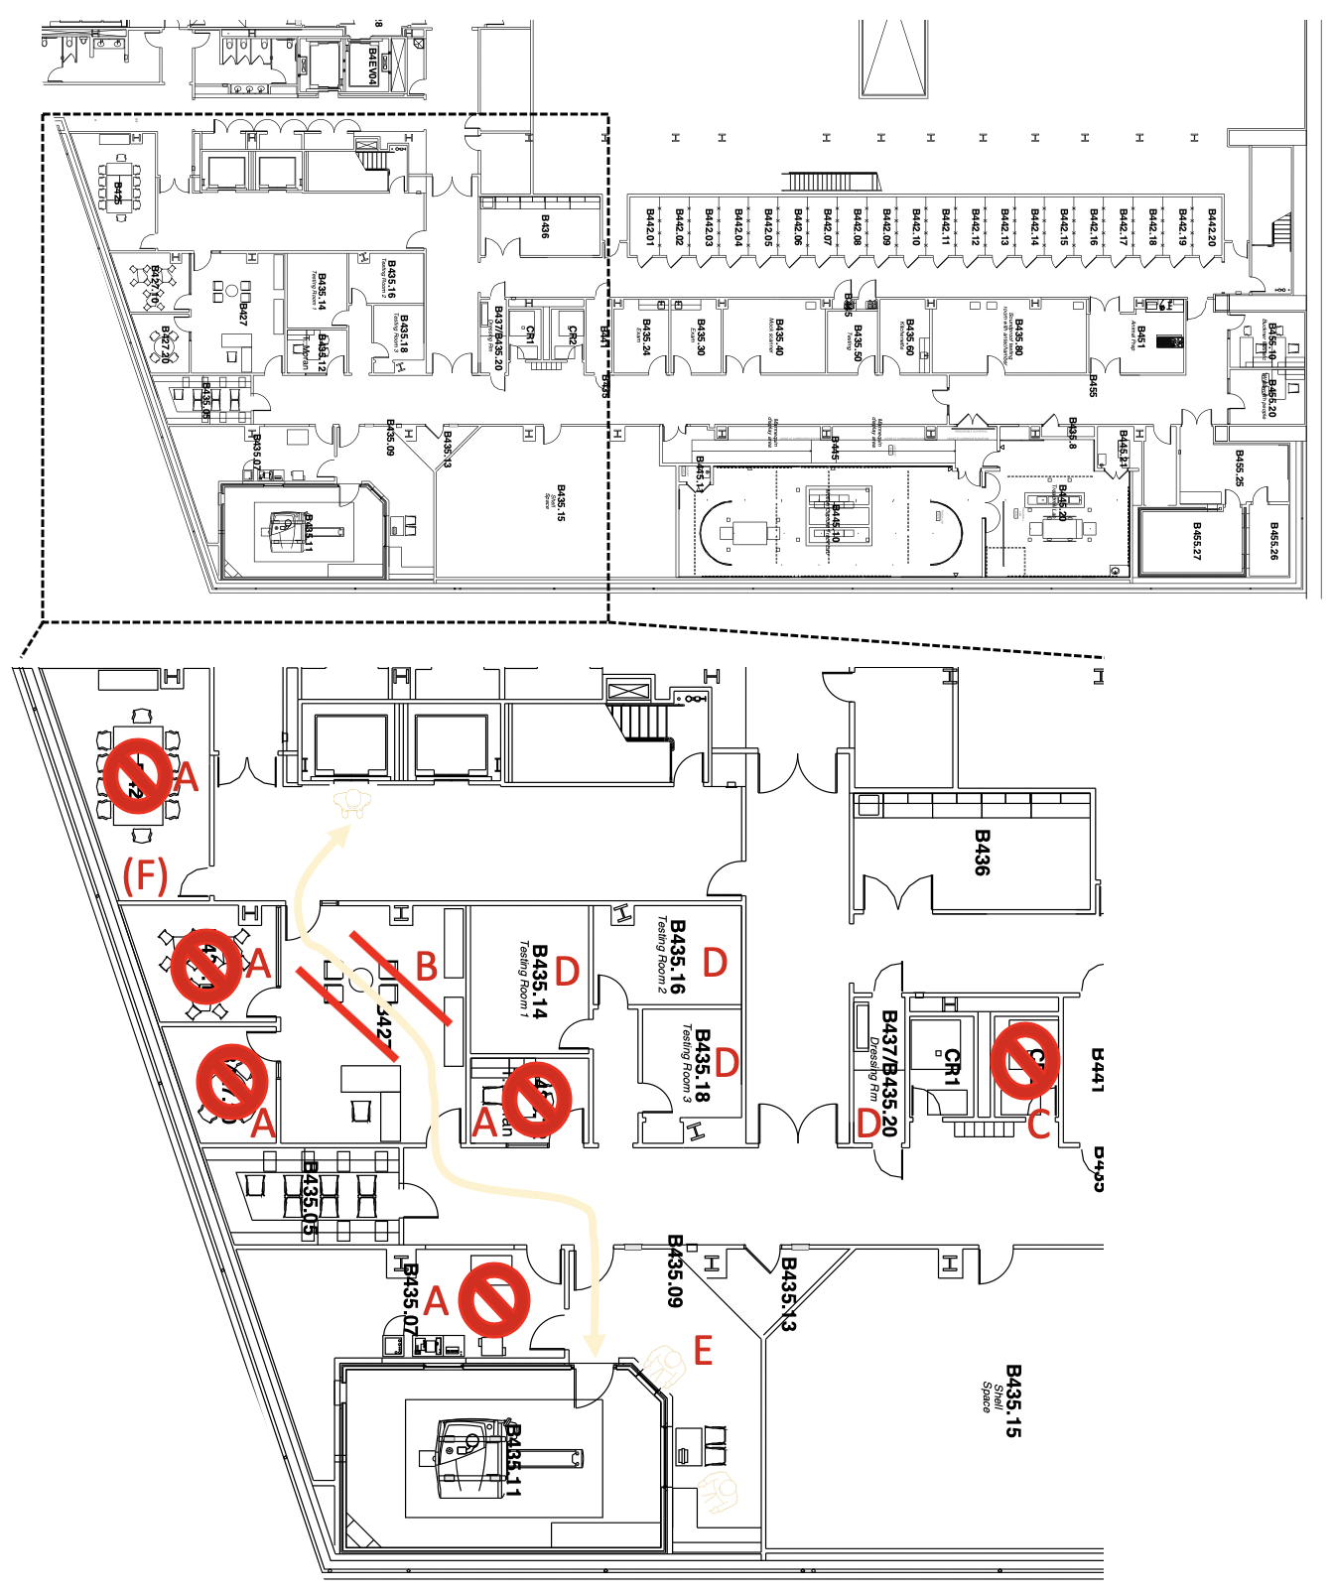

- Temporal Separation

[Add plans for temporal separation. This may include having different blocks for workers over different days and/or within a single day, having aerosol dissipation gaps between the blocks, etc. If there are plans for purchasing more equipment and/or tools for making temporal separation, they can be added here.]
[Timetables with labels of different working blocks and aerosol dissipation gaps are highly desired. Below is an example from CBS Neuroimaging Lab.]

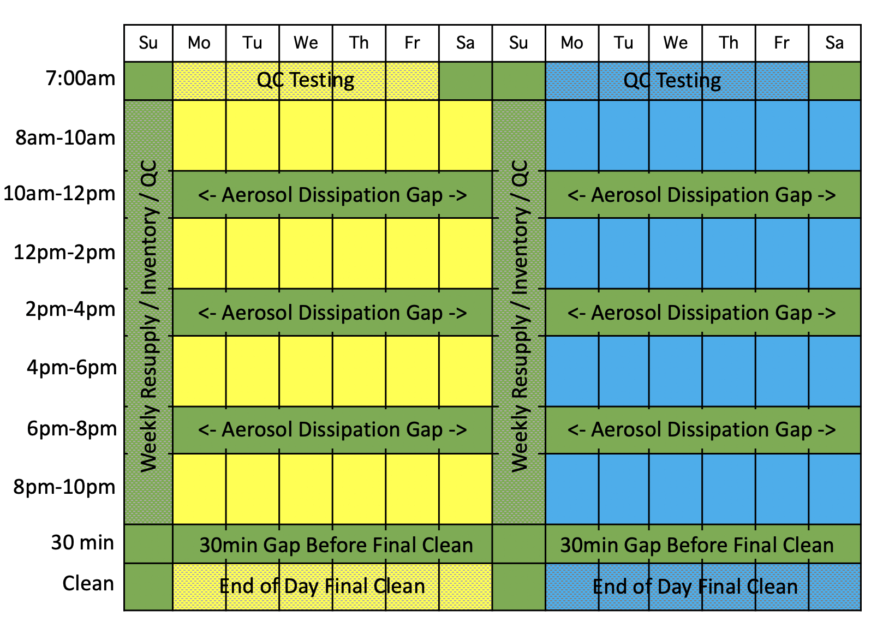

- Hand Washing Stations

[Add plans for using hand washing stations. This may include recommending the use of specific hand washing stations for different group of people (both for investigators and participants), having schedules for cleaning/sanitizing the spaces, etc.]
[Floor plans with labels of hand washing stations and paths to get there are highly desired.]

- General Precautions and PPE for Researchers and Participants

[Add general precautions and PPE usage for researchers and participants. Most precautions are common across most human subject research, so they can be copied from general guidelines or other example SOPs. If there is PPE specific to this facility, please add them here with their safe procedures (e.g. where to store, whether it is disposable, etc.)]

- Disinfecting Procedures

[Add procedures for cleaning and disinfecting the area and common appliances (e.g. devices, computers, desks, tables, and chairs, doorknobs, light switches, etc.). This can be outlined based on the timing of disinfecting, e.g. before and after each working block, before and after each participant visit, and/or based on the location/items of disinfecting, e.g. specific device, specific room, etc.]
[Appropriate cleaning materials should be outlined for different items. check EPA (US Environmental Protection Agency) website for the full list of disinfectants for use against SARS-CoV-2.]

- Ventilation and Local Filtration

[Add analysis of ventilation for the testing location. As per the University facilities guidelines, available filtered or fresh airflow should always exceed 100 cfm per person. Include available airflow data and calculate the maximum occupancy from the ventilation perspective, including participants and all research team members.][If the building ventilation is not enough, consider purchasing/using HEPA filters in order to boost local air filtration. This may include the number of HEPA filters to be purchased/used, a floor plan with the locations of HEPA filters, etc.]

- Appendix I: List of Available PPE, Disinfectants, and Local Filtration

[Add or modify items in the list depending on the specific facility. Potential items to be added include UV sterilizer, CIDEX OPA, detergent etc.]

PPE:
Vinyl Gloves – medium 0
Vinyl Gloves – large 0
Latex Gloves – medium 0
Latex Gloves – large 0
Nitrile Gloves – medium 0
Nitrile Gloves – large 0

3-ply disposable masks 0
Face shields 0
Disposable Gowns 0

Disinfectants:
Clorox and Lysol wipes 0
Hand sanitizer 0
Disinfectant mop pads 0

Other Relevant Supplies:
Kimwipes 0
Saran wrap 0
Keyboard covers and mouse covers 0

Wastebaskets 0
Automated Soap dispensers 0

Non-contact thermometer 0

Local Filtration:
BlueAir 211+ Air Purifier 0

